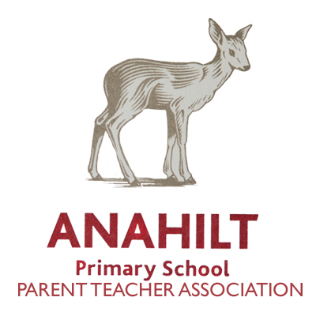
WE NEED YOU!

The Principal, Staff, Children and the PTA really appreciate all your help and support throughout the year. Without your help we would not be able to offer the children all the experiences currently on offer at our School.

This year is no different and there are lots of ways you can help support your school. We know you are a very intelligent lot and have lots to skills to offer!

Can you help with any of the following?

- Graphic Design/ IT Skills
- Accountancy Skills
- Painting and Decorating
- DIY Skills
- Gardening
- DJ for school disco
- Arts & crafts
- Catering / Baking
- Supervision at events

Does your employer offer any charity donations to local charities or matching donations programmes?

Could you or your employer help with donations to any of our events or raffle prizes for our Christmas Fair?

If you have any ideas or suggestions to help support Anahilt PS or the PTA please let us know.

If you think you, your business or employers can help in any way or you would like to volunteer your services please contact the school office or any member of the PTA (for a list of members see the school website).

Many Thanks in advance for your ongoing support.

Elaine Douglas
Chair, PTA



