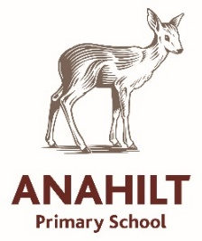
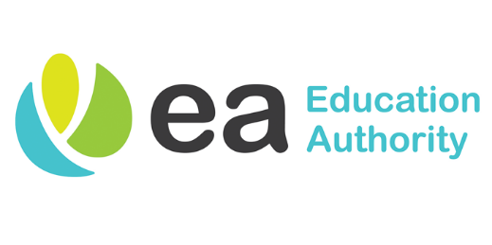

26 June 2025

Dear Parents
You spoke, and we listened.
We believe there is little value in sending out questionnaires unless we genuinely consider your feedback. As we near the end of another successful school year, I am excited to share some important updates about our class structure for the upcoming academic year.
Thanks to prudent budget management, a steady rise in pupil numbers, and a bit of good fortune, we are thrilled to announce a major change in how our classes will be organised starting this September.
What’s Changing?
Beginning next year, each year group will have its own dedicated teacher. This marks a shift away from the composite class model we have used in previous years. We believe this change will allow us to better cater to the individual needs of our pupils and offer a more focused and consistent learning experience.
Here is the teacher allocation for 2025–26:
- P1 – Mrs Humphreys
- P2 – Miss Carson (covering Mrs Hanna’s maternity leave)
- P3 – Mrs Purdy
- P4 – Mrs Irvine
- P5 – Mr Shields
- P6 – Mrs McCune
- P7 – Mr Smyth/Miss Smyth (no relation)
New Initiatives
We are pleased to announce the launch of the Anahilt Afterschool Club, part of our extended schools programme and built on an educational foundation. Mrs. Nelson, a member of our school staff, will oversee daily activities and supervise the children.
The club is open to all Anahilt pupils and aims to support working parents or those unable to collect their children at the usual time or want to keep siblings pick up time together. Please note this is not a homework club, and homework will not be completed during this time. Places will also initially be limited to 16 pupils per hour.

Afterschool Club Details:
Operating Hours: Term time, Monday to Friday, 2pm–4pm
- P1–P3: Join at 2pm
- P4–P7: Join at 3pm
Cost: £3.50 per hour
Early Birds will continue from 8:00am to 8:45am. While we’re unable to provide breakfast due to location and staffing constraints, this service offers an early drop-off option for working parents.
- Cost: £2.50 per session
We cannot overstate how much the success of the Afterschool Club depends on your support. For context, our Early Birds programme currently runs at an annual loss of approximately £1,500—a cost we are willing to absorb to provide this essential service. However, we cannot sustain similar losses for the Afterschool Club.
If you have any questions or would like to discuss this further, please contact the school office.
Communications
For the 2025/26 school year, we are also exploring ways to improve our communication methods. This includes increasing the use of email to reduce paper usage and considering other digital options.
We are also evaluating online payment systems. At present, the options are either highly efficient but expensive, or more affordable but time-consuming. We will keep you updated as we explore the best solution.
As always, more changes may arise throughout the year. What we can promise is that every decision we make will prioritise the best interests of our pupils to enhance their educational journey here at Anahilt.
Regards,
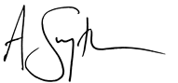

A Smyth
Principal

