Hi P5,

I am so proud of how hard you all worked last week. Having to adjust to home schooling (once again!) is a challenge for everyone but I have been so impressed with how well you have adapted to using Seesaw and the school’s website to continue your learning at home.

Things are going to be set out a little differently this week. By now your parents have probably lifted your Home Learning Pack from school, which contains some books and other resources that you can use to work from. I have provided a hard copy of most of the resources that you may need this week, however I will continue to post some of these activities on Seesaw for those who prefer to annotate and submit their work through the app. If you are enjoying Seesaw, please feel free to continue to use this when possible. You can also use it to send me images of your work.

You will also need to use our class page on the school’s website to access any PowerPoints that I have created; I cannot upload these onto Seesaw. It will probably take a few days to get ‘into the swing of things’ again but I hope that you find the guidance and materials provided, easy to follow and access.

Below I have outlined a number of activities for you to complete this week. There is no pressure on you to complete all of the work; just try your best!

Numeracy
- Complete one set of Mental Maths per day (Monday-Thursday);
- 2D Shape; our new numeracy topic is 2D shape. I have planned 4 separate lessons for you to complete in your own time. Please stick the Fact sheets into your Maths FTL book.
- Lesson 1: Follow the ‘2D Shape intro’ PowerPoint on our school’s website; this will revise key terminology, basic 2D shapes and their properties, as
well as right angles. Then, complete pages 1-10 in your ‘2D Shape- Green Group’ booklet. Use your fact sheets to help you with this. Finally, complete the ‘2D Shape Sort’ activity on Seesaw.
- Lesson 2: Follow the PowerPoint titled ‘Types of Triangles’. Then, complete page 11 in your booklet. After that, record the answers to the ‘Triangles’ worksheet in your Maths Classwork Book.
- Lesson 3: Follow ‘Parallel and Perpendicular Lines’ PowerPoint. Complete the final two pages in your booklet. Next, record your answers to the questions on the ‘Parallel and Perpendicular’ worksheet. You can do this on the sheet or in your Maths Classwork Book.
- Lesson 4: Complete NHM4 textbook pages 107-109. I have included some dotty paper for page 109.

Literacy
- Daily English (Stop after day 18);
- Literacy: I will outline a potential series of lessons for you to complete this week. However, you can complete the activities in your own time and at your own pace.
- Lesson 1: Read ‘Cat’s Eyes’ Unit 6 and complete the first three sections: Comprehension, Study Skills and Word Study.
- Lesson 2: Grammar: Complete the grammar worksheets on ‘Apostrophes’. A copy of these is in your pack but you can complete them on Seesaw if you wish.
- Lesson 3: Complete the remaining sections of Unit 6: Language Study and Writing Workshop. These will revise last week’s grammar work on verb tenses and this week’s apostrophe work.
- Lesson 4: Percy Shaw is a famous inventor. I would like you to become an inventor for the day and design your own product. Draw your product on the ‘My Invention Design’ Sheet and label it. After this, describe what your invention is and explain what it does.
*Monkeys: Please complete your spelling activity sheets instead of lessons 1 and 3.

TWAU

Life after the Stone Age:
- Read the ‘Life After the Stone Age’ eBook (available on the school’s website) and the ‘After the Stone Age Fact Cards’. Use the information in these to answer the questions on the document titled, ‘Life After the Stone Age Task’. I have included a hard copy of this worksheet in your Home Learning Pack. You do not have to answer the questions in full sentences.
- Follow the ‘Stone Age to Bronze Age’ PowerPoint and complete Activity 7A and 7C. A hard copy of these worksheets can be found in your Home Learning Pack.
- Follow ‘The Bronze Age’ PowerPoint and watch the video linked on slide 2. This is also available on: https://www.bbc.co.uk/teach/class-clips-video/story-of-britain-bronze-age-britain/znrygwx
Then, complete activity A and B on slide 3 and 4. You can record your thoughts in your TWAU book.

Optional Extra:
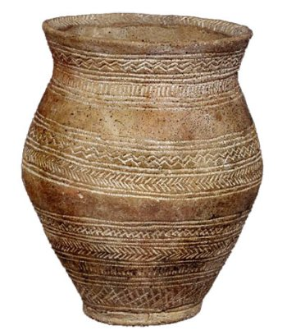
- Design your own Bronze Age pot or necklace; you can draw these by hand or get creative and make your own 3D version! Use the images below for inspiration.
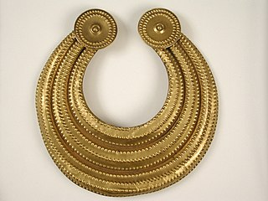

Enjoy another productive day of learning from home,
Miss Sharratt

