Dear Parent

Here are a few tasks that your child can complete at home on Wednesday.
Please encourage your child to try their best and complete what they can.
Thank you
Mrs H Purdy

Maths task 1 - Interactive game - 10 more, 10 less

Please use the QR code provided to access this interactive game. The link will take you to an online activity where your child practises finding 10 more and 10 less than a given number. Children select the correct answer from the options shown. Encourage them to use a hundred square if needed and to explain their thinking aloud.
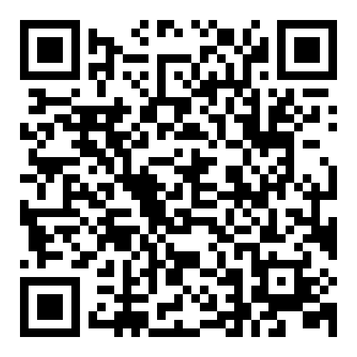
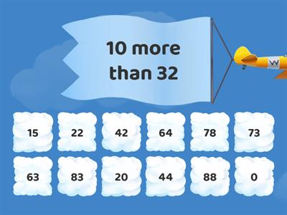

Maths Task 2 Carroll Diagrams Odd and Even
Please use the QR code provided to access this interactive game. The link will take you to an online activity where your child will
develop an understanding of sorting numbers on a Carroll diagram using particular properties as criteria. Numbers are sorted by two conditions. In Level 1 numbers are sorted into odd or even and more or less than either a number up to 10 or in Level 2 up to 99.
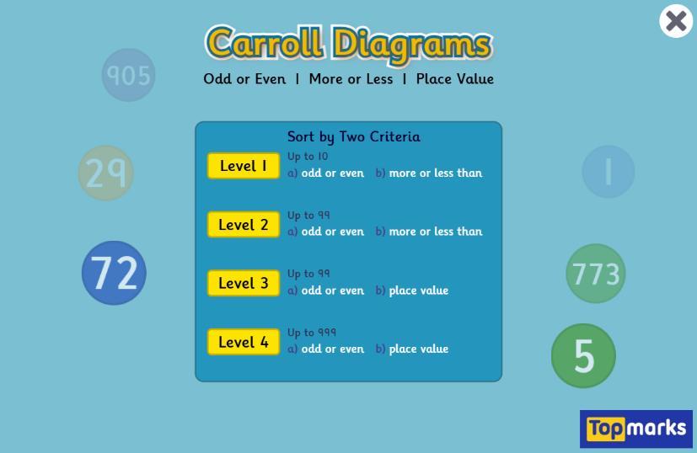
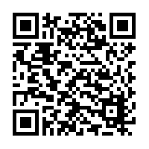
QR CODE Scan this on mobiles and tablets to quickly open this web page.

Literacy task 1 Writing a Fish Report

Your child will choose a fish and create a short report about it. They will first collect key words and facts, then turn these into full sentences.

What to Do
- Choose a fish with your child (for example: goldfish, clownfish, shark, salmon).
- Use the internet together to find simple facts about the fish. Websites for children such as National Geographic Kids or DK Find Out are very helpful.
- On a sheet of paper, draw a table with the following headings:
What it is | What it looks like | What it eats | Where it lives | Interesting facts
- Under each heading, help your child write key words or short phrases, for example:
  - orange, small, lives in the ocean, eats seaweed, fast swimmer
- Once the table is completed, encourage your child to use the words and phrases to write full sentences to create their fish report.
Example: A clownfish is a small, brightly coloured fish. It has orange and white stripes…
- If they would like to, they can also draw a picture of their fish.

Literacy task 2 - Interview Someone About School in the Past
In class, your child is learning about what school was like a long time ago.
Your child’s task:
Ask an adult (for example, a grandparent, parent, neighbour or family friend) about what school was like when they were a child.
Your child should write their interview on a sheet of paper.
Here are some example questions they might use:
- What was your favourite lesson?
- What happened if children were naughty?
- What games did you play at playtime?
- What did your classroom look like?
- How did you get to school?

Interview Sheet (to be completed on paper)
Question:
(Your child writes their question here.)
Answer:
(Your child writes the adult’s answer here.)

Your child may add extra questions if they wish.

The World Around Us Task

Your child will think about five different ways they can help take care of their planet.
- On a sheet of paper ask them to draw five boxes.
- In each box, ask your child to draw and write a caption to describe what they have drawn.

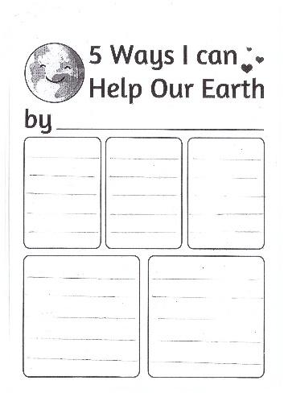
Here are some ideas to help your child get started:
- Recycle paper, plastic, and cans.
- Turn off the water when brushing your teeth.

Create a Poster Ask your child to choose one of their five ideas. They can create their poster using paper and colouring pencils/pens or use a computer. Encourage your child to design a bright and eye-catching poster to encourage others to help the Earth too. The poster should include a catchy caption (short and powerful words that grab attention) and a picture or images that match their idea.
Caption ideas:
- “Be a Planet Protector!”
- “Small Actions, Big Difference!”
- “Turn It Off, Save the Planet!”
- “Recycle Today for a Better Tomorrow!”
- “Keep Our Earth Clean and Green!

