P7 PLAN WB 30/03/20
HI P7- I hope that you are all safe and well and have adapted to life at home. I’ve taken up cycling as my daily exercise which I am really enjoying. I hope that you are all getting some form of exercise too! Here is your plan for the week:
- Please complete x1 Mental Maths and English per day from your pack
- MATHS: WEIGHT - P6s are doing WEIGHT this week – those of you with NHM 5 can follow the P6 Plan. The rest of you can do NHM 6 Pgs 68-70, if you can!
- Do TOPIC ASSESSMENT 9 Weight from your Assessment Books!
You may enjoy/benefit from the following videos on Weight:
https://www.bbc.co.uk/bitesize/clips/zbvgkqt
https://www.bbc.co.uk/teach/class-clips-video/maths-ks2-using-grams-and-kilograms/zm7tf4j
- ENGLISH: Complete the Easter Comprehension work (scanned document)
ARTWORK – OPTIONAL
P7s I know you love your Art so why not……

- Design an Easter Card for a member of your family. Be creative! Can you make a pop-up chick card?

- What about drawing or painting a fancy Easter Egg on A4 or A3 paper (if you have some) and stick on your window for the family to enjoy. Use materials if you can. Or what about some Easter Bunnies?
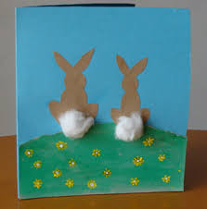




- You could hard boil some eggs and make a family
- You could try some Easter decorations if you have some materials at home. HAVE FUN!



