P7 Week Beginning 06/04/20


Hi P7 – I hope that you managed to complete the work that I set you last week and that you feel you have a good understanding of Weight. The next two weeks are your Easter Holidays so a VERY …….

ARTWORK – OPTIONAL If you haven’t already done so, why not try the following:
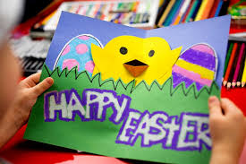
- Design an Easter Card for a member of your family. Be creative! Can you make a pop-up chick card?

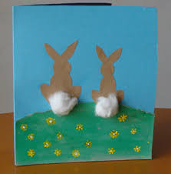
- What about drawing or painting a fancy Easter Egg on A4 or A3 paper and stick on your window for the family to enjoy. Use different materials if you can. Or what about some Easter Bunnies? ENJOY!
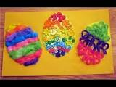
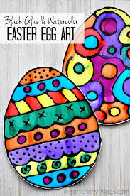


- You could hard boil some eggs and make a family.

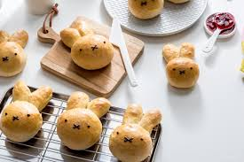
- Try making some simple buns for Easter.
(There are many recipes online)


Have a lovely Easter P7 with your family. I hope you get to enjoy some Easter eggs and Easter treats! I shall update the next plan on 20/04/20! Mrs McC

