P7 Week Beginning 4/05/20
Hi P7 – I hope that you all got on well with the work last week and that you feel you have a good understanding of the topics covered. I hope you enjoyed your research and write up on Co. Antrim and Co. Fermanagh. I really enjoyed reading them. Well done to everyone who participated – your work can still be emailed.
Try to complete the following activities this week to help you prepare for year 8:

MATHS
Please do one Mental Maths activity per day Monday-Thursday

NUMBER PROPERTIES – CONTINUED…..

- WATCH the 4 PowerPoints on NUMBER PROPERTIES BEFORE completing the written work as these will help with your understanding. You have covered this in P6 so most of this is revision BUT very important for Year 8. Make sure that take the time to study the PowerPoints very carefully as they will help you with the written tasks. Then ……

- COMPLETE NHM 6 Pg 35 (the product of even/odd numbers)
- COMPLETE NHM 6 Pg 37 (divisibility by 3, 4, 6, 8)
- COMPLETE NHM 6 Pg 38 (multiples)
- COMPLETE NHM 6 Pg 39 (factors, primes)
- COMPLETE NHM 6 Pg 40 (using and applying)
- TEST to consolidate your understanding – COMPLETE Topic Assessment 5a and 5b from your NHM 6 ASSESSMENT BOOKS

(Parents to mark all work– I have uploaded answers. Pupils to correct and understand errors)

ENGLISH
- NB: Complete 4 Mental English a WEEK instead of 5!
Parents to mark

P7s You were due to be off school Friday 8th May and we are going to learn why…..

The English Focus this week is on VE DAY:
- WATCH the two PowerPoints about VE DAY
- COMPLETE the COMPREHENSION (SEE UPLOAD) Answers provided
- COMPLETE The Daily News Task Answers provided
- OPTIONAL ACTIVITIES (UPLOADED) for those who would like to complete these

TWAU /ICT – NORTHERN IRELAND
- Research and write/type up in your own words (NO copy and pasting) an A4 page about Co. Armagh in paragraphs and/or bullet points OR create a poster of facts/info. about Co. Armagh
- Write/type up in your own words (NO copy and pasting) an A4 page about Co. Londonderry in paragraphs and/or bullet points OR create a poster of facts/info. about Co. Londonderry
- Email me your work!
- Glue a copy of each into your TWAU books!

OPTIONAL EXTRA
Complete the mindfulness colouring in sheet
on The Giant’s Causeway- found under P6 Section
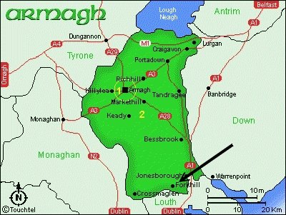
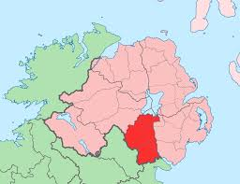

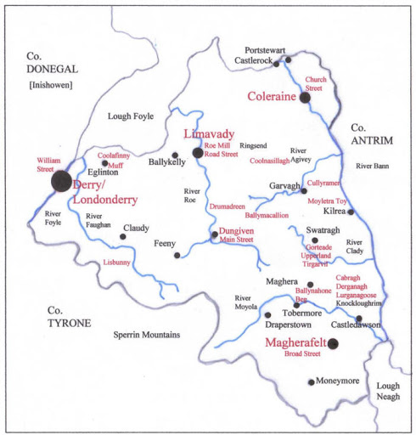
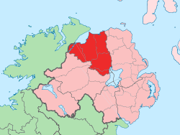

P7s – When you run out of pages in your Maths and English classwork books, continue your work in your Maths and English Homework books!

