P7 Week Beginning 18/05/20
Hi P7 – I hope that you all had a great weekend and enjoyed two days off from home learning! You are all doing so well with your home-schooling routine and I am so very pleased and proud of all your efforts. It takes determination and dedication to keep working away week after week so very well done to you all. A big thank you to parents too for supporting, teaching and encouraging you so far. I hope you enjoy another week of learning at home – I know you can do it P7!

Try to complete the following activities this week to help you prepare for year 8:

MATHS
Please do one Mental Maths activity per day Monday-Thursday
TOPIC: POSITION, MOVEMENT, ANGLE
For teaching and learning please watch the following:
- WATCH PowerPoint 1 on Position, Movement, Angle
- WATCH PowerPoint 2 on Position, Movement, Angle
Now you are ready to…
- COMPLETE NHM 6 Pgs 106-109 (If you have no tracing paper, try greaseproof paper!)
- COMPLETE NHM 6 TOPIC ASSESSMENT 15a

Now, let’s revise and recap Angles by watching/studying and understanding the following…
- Please watch this VIDEO from BBC Bitesize on Angles… https://www.bbc.co.uk/bitesize/topics/zb6tyrd/articles/zg68k7h
- Please watch PowerPoints, titled Types of Angles 1 and 2 as this will remind you of the different types of Angles (See Upload)
- Please watch/do activities on PowerPoint, titled Missing Angles
- Please study the PowerPoint, titled Interior Angles
- COMPLETE ANGLE QUIZ – online PowerPoint
- STUDY sheet on ANGLES and GLUE into FACTS to LEARN
- GLUE TYPES of ANGLES into FACTS to LEARN
- COMPLETE and GLUE into FACTS to LEARN ANGLES & LINES (See Scans)

Now you should be ready for the written tasks:
- COMPLETE Pg 110 if you have a protractor at home! If not, estimate only and see if your parents agree!
- COMPLETE Pg 111 – no protractor required!
- COMPLETE TOPIC ASSESSMENT 15b (in your NHM 6 Assessment Books)

Parents – Please mark all work and children to complete corrections. Answers uploaded.

ENGLISH
- Complete 4 Mental English this week Parents to mark

- WRITING: Factfile – Complete Template My Favourite Film Character
(See Scans) then please email me your work! If Mrs McC was completing this, I’d select Liam Neeson – my fav!

TWAU /ICT – NORTHERN IRELAND
- Research and design an information leaflet on publisher or by hand, which encourages tourists to visit NI. You might choose to include sections on:
- The geography of NI
- Climate
- History
- Places of interest
- Food
- Famous people
- Fun Facts or county by county!

Use the info in your TWAU books to help you

- Email me your work!
- Staple a copy into your WRITING books!

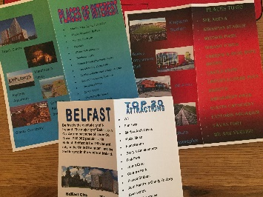
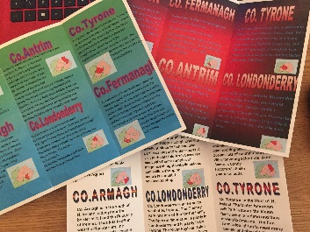
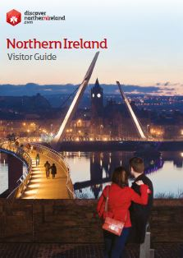
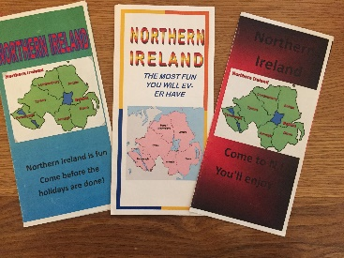
See some examples from past pupils….

OPTIONAL ART:

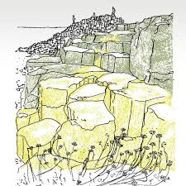
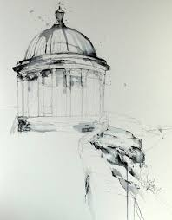
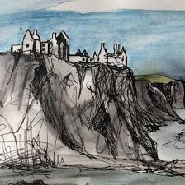
Sketches of places in NI eg…..
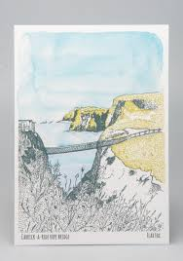
Please forward photo of your Art, if you choose to do it! I’d love to see them!
Enjoy another week of home school P7
Mrs McC

