P6 (AQE GROUP) Week Beginning 25/05/20
Hi P6 – Thank you P6 for all my messages/cards etc on Thank A Teacher Day. I really enjoyed them. I also enjoyed reading your work on your favourite film character and your WAU work. You have been doing a fantastic job working from home and it is great receiving regular updates. Today is Bank Holiday Monday so I have tried to set less work this week to enable you to have the day off! Do something fun and start the work tomorrow. Enjoy!
I hope you enjoy another week of learning at home – You are now pros, P6!
Please try to complete the following activities this week, or just as much as you can: Remember to prioritise Maths and English as AQE is proceeding in Nov/Dec!

MATHS
Please do one Mental Maths activity per day Monday-Thursday starting at Page 62 (Parents to mark – I have scanned the answers)

TOPIC 7 – Angles – continued….

For the teaching & Learning…
- Recap on the video and PowerPoints, if necessary!

Written tasks…..
- COMPLETE SPMG 4 Pages 83-85 (See Scans)
- COMPLETE Workbook Page 24 (this was in your pack in a poly pocket titled Maths Worksheets) You need this page for Pgs 83 and 87
- COMPLETE SPMG 4 Pages 87-88

TESTS to consolidate learning….
- COMPLETE PROGRESS TEST 24, titled Shape (Stage 3)
- COMPLETE PROGRESS TEST 24, titled Shape (Stage 4)

Less Maths this week, due to Bank Holiday Monday!

Parents please mark the work above (answers included). Pupils to do corrections and understand errors. Please check that Facts to Learn Books are up to date, thank you.

ENGLISH
Complete 4 Mental English (Days 39-42) Parents to mark – I will scan answers
NO writing or comprehension due to Bank Holiday Monday!
- Complete Dictionary Activity 14 (In a booklet – answers are in the pack) Learn these words and their definitions and, if time allows, record in your vocab extension book.
- Complete SPG Alphabetical Order (Pg 15) (Answers provided in pack)
- Read! Try to read a little a day! This will help to expand your vocabulary!

COMPLETE AQE TEST 10 please by Friday. Email results please. DO CORRECTIONS
and try to understand errors with parental support.

TWAU – NORTHERN IRELAND
- Research popular foods / dishes that come from Northern Ireland
- Write or type on the computer, using your research, a typical ‘Northern Irish’ Menu
- OPTIONAL EXTRA: Why not try to make some of the foods yourself?
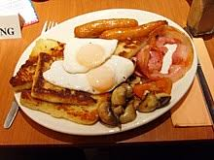
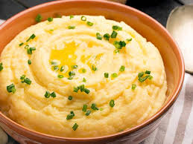
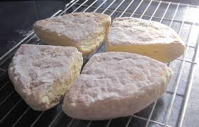
- Please Email me your work and/or photos!
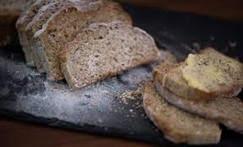
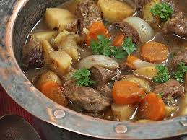

Look at the PicCollage to see some Menus by P7
OPTIONAL ART:
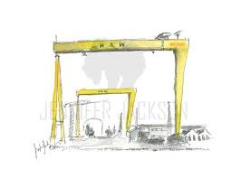
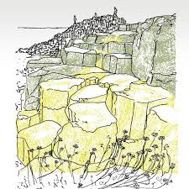
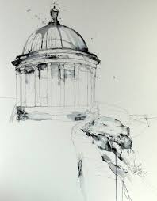
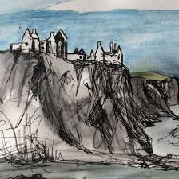
Sketches of places in NI if you haven’t already done so eg…..
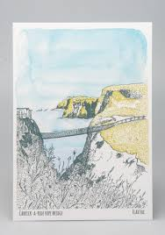
Please forward photo of your Art, if you choose to do it! I’d love to see them!
Enjoy another week of home school P6, Mrs McC

