P7 Week Beginning 25/05/20
Hi P7 –Many of you have been doing a fantastic job working from home and it is great receiving regular updates. It would be lovely for the few of you from whom I haven’t heard to get in touch and let me know how you are getting on. The brochures I received were very good P7 – well done. You should be very proud of your efforts! Some of you still have to complete and forward me this work. Today is Bank Holiday Monday so I have tried to set less work this week to enable you to have the day off! Do something fun and start the work tomorrow. Enjoy!
I hope you enjoy another week of learning at home!

Try to complete the following activities this week to help you prepare for year 8:

MATHS
Please do one Mental Maths activity per day Monday-Thursday
TOPIC: POSITION, MOVEMENT, ANGLE Continued………..

For the teaching & Learning…
- Recap on the video and PowerPoints, if necessary!

Written tasks…..
- COMPLETE SPMG 5 Pages 101
- COMPLETE SPMG 5 Treasure Hunt – Bearings Pages 102-103
- COMPLETE SPMG 5 Bearings at Sea Page 104

For teaching and learning ……
WATCH the PowerPoint on How to use a Protractor, then…….
- COMPLETE SPMG 5 Navigating Page 105 (Ruler and Protractor needed)
- COMPLETE SPMG 5 Estimating and Measuring, Page 106 if you have a protractor!

All these pages have been scanned. Parents to mark and pupils to do understand errors, with parental support and do corrections.

The answers to the above pages are missing from the Answer Book. I will be in school on Tuesday and I will check to see if I can find another book with the answers !

NB: If you find the above SPMG 5 work too challenging, please complete the SPMG 4 work pages instead. You will find these in the P6 Section.

ENGLISH
- Complete 4 Mental English this week Parents to mark
- This is when we would be busy preparing for our final P7 assembly and doing various different write-ups about our experiences. One popular piece is creating a poem about APS. This could be an acrostic, using the letters ANAHILT or a verse poem, rhyming or non-rhyming or even a rap! WRITE or TYPE up a school poem, titled Anahilt and email me a copy! (You may remember hearing some from last year)

TWAU /ICT – NORTHERN IRELAND
- FINISH your information leaflet on Publisher or by hand, which encourages tourists to visit NI. You might choose to include sections on:
- The geography of NI
- Climate
- History
- Places of interest
- Food
- Famous people
- Fun Facts or county by county!

- Email me your work!
- Staple a copy into your WRITING books!
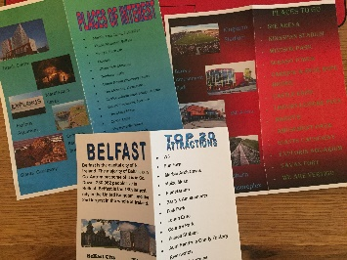
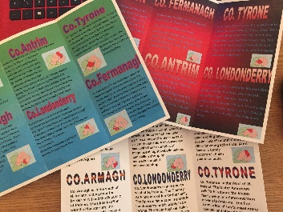
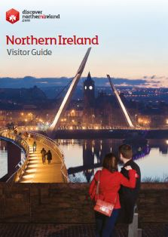
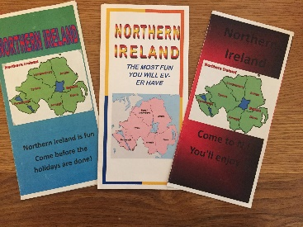
See some examples from past pupils….

ART:

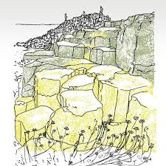
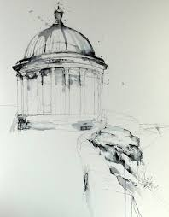
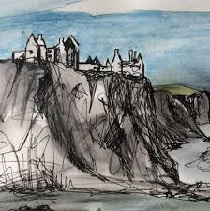
Sketches of places in NI if you haven’t already done so eg…..
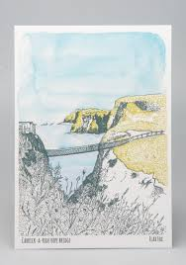
Please forward photo of your Art, if you choose to do it! I’d love to see them!
Enjoy another week of home school P7
Mrs McC

