P7 Week Beginning 8/06/20
Hi P7 – You have your new schools now to look forward to P7! I know a few of you did not get your first choice but as I said last week, all schools in our surrounding area are very good and they have lots to offer! You will succeed and do really well if you work hard at whatever school you attend. It is a very exciting time P7 and something to look forward to. This week you will have the opportunity to research and learn all about your new post primary school as well as some more work on Titanic!
Try to complete the following activities this week to help you prepare for year 8:
MATHS
Mental Maths should now be complete!

TOPIC: VENN & CARROLL DIAGRAMS/ Revision… (Very short!)

For the teaching and learning…..

- WATCH the following VIDEO FIRST: https://www.bbc.co.uk/bitesize/clips/zhckq6f
- DO the interactive PowerPoint 1 Using a Venn Diagram (Click on the shapes)
- DO the interactive PowerPoint 2 Sorting Shapes Using A Venn Diagram (Click on shapes)
- WATCH the following VIDEO on CARROLL DIAGRAMS https://www.youtube.com/watch?v=C02Bd3-tM9k
- DO the interactive PowerPoint 3 Sorting Shapes Using a Carroll Diagram

NO written Maths tasks this week P7, just the online interactive work above! This will give you plenty of time to focus on your Leaver’s tasks, post primary work and TWAU activities.

ENGLISH/ICT
Daily English should now be complete!
- LEAVER’S WORK: Type (or write) ‘My Successes’ – Think about all you have managed to achieve at Anahilt PS! Think about all the subjects you have studied and your progress and what you are now able to do. Also include winning of badges, eg swimming badge, certificates, awards and competitions etc while at APS. Record in paragraphs and try to be as detailed as possible. Please Email me this work.

- LEAVER’S WORK: Type (or write) ‘Funny Bits’ – Think about all the funny things that happened at APS. What made you laugh? Think about April Fool’s Day pranks, funny accidents and/or misunderstandings! Record in 3-4 paragraphs. Please Email me this work.

- POST PRIMARY WORK: Please research your new school via their website! Read and learn as much as you can. Then produce a PowerPoint Presentation about your new school! This activity will give you a really good insight into your next school P7.

Use this plan as a guide:
SLIDE 1 – Title Page (School name with photo/logo etc)
SLIDE 2 – Brief history of the school, its values and aims, its location
SLIDE 3 – The Uniform – include PE uniform also and add images
SLIDE 4 – The Curriculum – what subject are taught?
SLIDE 5 – The School Day – the timings for each period etc/break and lunchtimes!
SLIDE 6 – After School Activities – find out what is on offer!
SLIDE 7 – School Trips – What times are usually offered?
SLIDE 8 – House System – Find out how this works!
SLIDE 9 – The School Canteen – what is available? What are your options at
lunchtime?
SLIDE 10 – Other Resources – What does your new school have which is
useful/interesting?
SLIDE 11 – Conclusion – Summing up – why this school is a good school etc
You can add more information/slides if you need to! Try to add appropriate images to
every page. Remember you don’t need to write long paragraphs in a PowerPoint –
bullet points of the key facts/information will suffice! ENJOY! Please Email me this work.
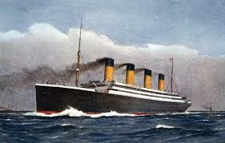

TWAU - TITANIC
- READ more about the Titanic on this website: https://www.coolkidfacts.com/titanic-facts-for-kids/
- COMPLETE the TIMELINE ACTIVITY. To do this you need to print, then cut out and glue onto blank page/s in the correct order! Take care to check dates and times! (Answers provided later!)
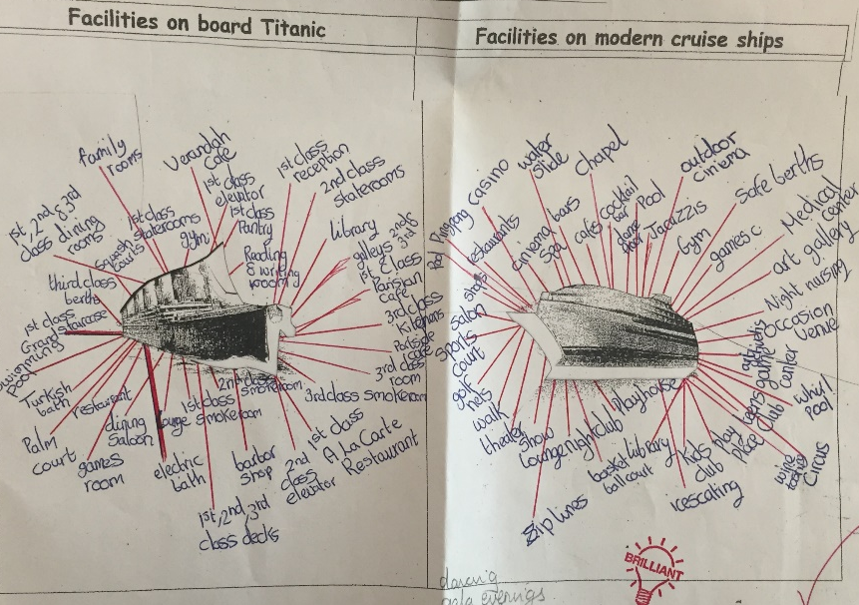
- Check out the facilities on board the Titanic versus a modern cruise ship and create labels around appropriate images of Titanic and a modern cruise liner, similar to the example below. Alternatively create a mind map instead! Print colour pictures and do your own research! Make sure you add titles to your work!
- PLEASE Email me photos of your work, thanks.

ART - TITANIC

Try to draw the Titanic using chalks, crayons, pencils or other. In class we would try to draw the 1st one below in chalk on a black background but at home you can choose your own design. Google images of the ship will help you! There are YouTube videos and tutorials to help you draw the ship.
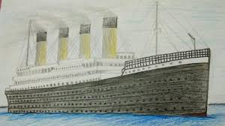
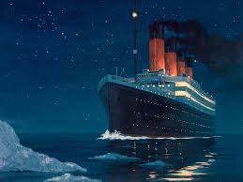
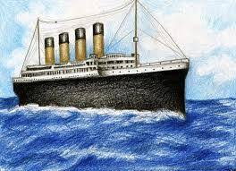
Email a photo of your drawing, please.

