P6 PLAN Week Beginning 8/06/20
Hi P6 – Only three weeks left to the summer holidays so not too long to go now! AQE Test 12 this week and then two weeks off! Phew – I am sure that you will all be glad of the break! I really enjoyed your PowerPoints on NI P6 – you have been busy beavers! Please take the time to read each other’s PowerPoints on the website so that you can see the different approaches you took and you might even learn something you didn’t know before. I hope you found the video and PowerPoints on Titanic useful last week and that you enjoyed your research task. More learning and artwork associated with the Titanic this week.
Please try to complete the following activities this week, or just as much as you can:
Completing the Maths and English is very important for those wishing to do AQE

MATHS
Please do one Mental Maths activity per day Monday-Thursday starting at page 66
(Parents to mark – I scanned the answers two weeks ago!)

TOPIC 8 Percentages Continued….
- COMPLETE worksheet titled Percentages (See Scan – Parents to mark and pupils correct and understand errors)
- COMPLETE worksheet titled Percentages NUMBERS 23 (See Scan – Parents to mark and pupils correct and understand errors)
- COMPLETE PROGRESS TEST stage 4 , Test 28 Number (Parents to mark and pupils correct and understand errors)

TOPIC 9 VENN & CARROLL DIAGRAMS

For the teaching and learning…..

- WATCH the following VIDEO FIRST: https://www.bbc.co.uk/bitesize/clips/zhckq6f
- DO the interactive PowerPoint 1 Using a Venn Diagram (Click on the shapes)
- DO the interactive PowerPoint 2 Sorting Shapes Using A Venn Diagram (Click on shapes)
- WATCH the following VIDEO on CARROLL DIAGRAMS https://www.youtube.com/watch?v=C02Bd3-tM9k
- DO the interactive PowerPoint 3 Sorting Shapes Using a Carroll Diagram

Written tasks…. (Please do the above section FIRST to help you to understand)

- COMPLETE the VENN & CARROLL DIAGRAM Worksheets
- COMPLETE the Multiples of 6, 7 and 9 Carroll Diagram worksheet
- COMPLETE the 11 Sets of VENN DIAGRAM QUESTIONS.

Parents please mark the work above page by page (answers included). Pupils to do corrections and understand errors. Please check that Facts to Learn Books are up to date, thank you.

ENGLISH
Complete 4 Mental English (Days 47-50) Parents to mark – I will scan answers
- Complete Dictionary Activity 16 (In a booklet – answers are in the pack) Learn these words and their definitions and, if time allows, record in your vocab extension book.
- Complete SPG Syllables (Pg 17) (Answers provided in pack)
- Read! Try to read a little a day! This will help to expand your vocabulary!

COMPLETE LAST AQE TEST 12 please by Friday. Email results please. DO CORRECTIONS and try to understand errors with parental support.
These tests must be completed within the hour and results recorded.
SUMMER TESTS TO FOLLOW…. for JULY/AUGUST
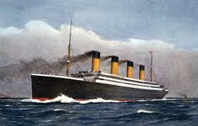

TWAU - TITANIC
- READ more about the Titanic on this website: https://www.coolkidfacts.com/titanic-facts-for-kids/
- COMPLETE the TIMELINE ACTIVITY. To do this you need to print, then cut out and glue onto blank page/s in the correct order! Take care to check dates and times! (Answers provided later!)
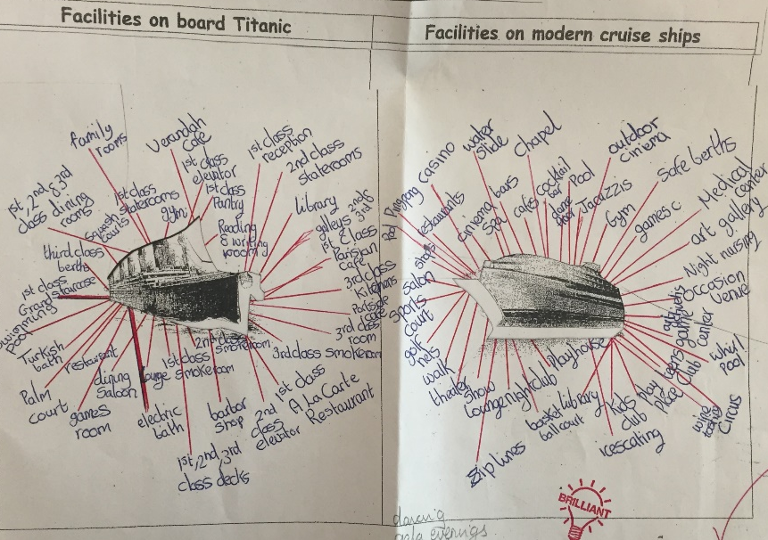
- Check out the facilities on board the Titanic versus a modern cruise ship and create labels around appropriate images of Titanic and a modern cruise liner, similar to the example below. Print colour pictures and do your own research! Make sure you add titles to your work!
- PLEASE Email me photos of your work, thanks.

ART - TITANIC

Try to draw the Titanic using chalks, crayons, pencils or other. In class we would try to draw the 1st one below in chalk on a black background but at home you can choose your own design. Google images of the ship will help you! There are YouTube videos and tutorials to help you draw the ship.
Email a photo of your work, please.
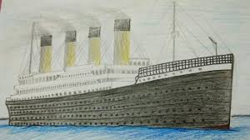
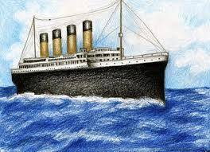
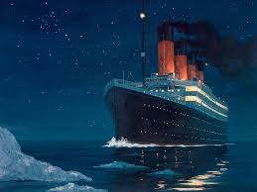

Enjoy another week of home school P6, Mrs McC

