
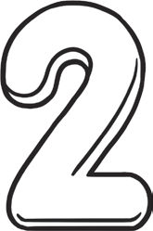
The A Team

Maths Number and Place Value Workbook

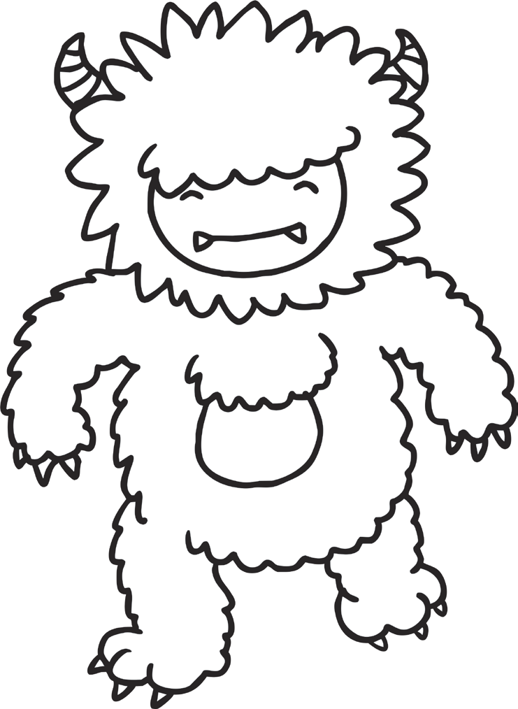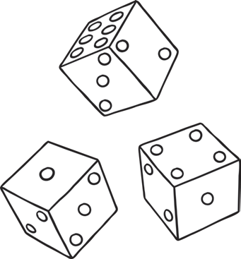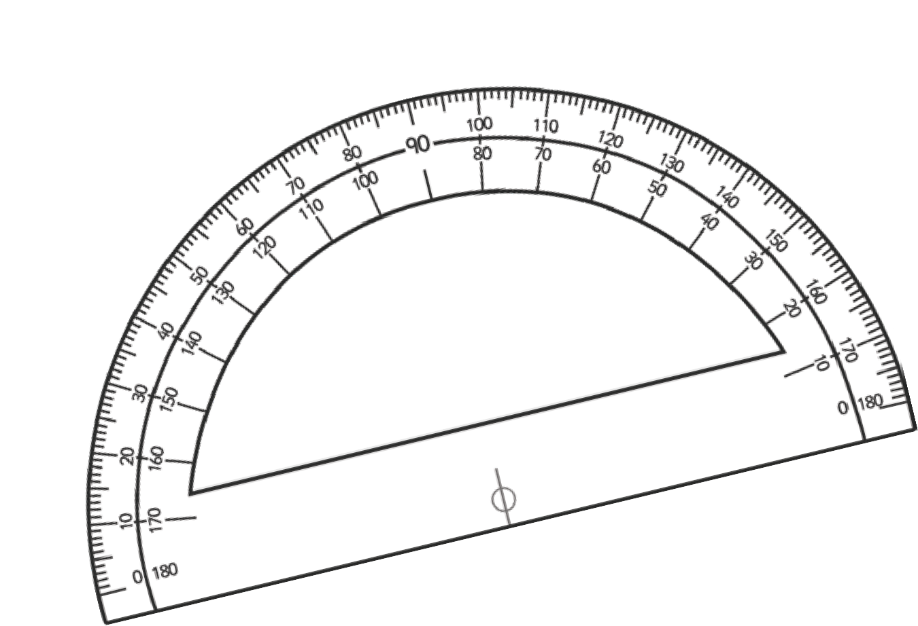

Home Learning –The A Team
Number and Place Value

Revision | Worksheet | Page Number | Notes
Count from 0 in multiples of 4, 8, 50 and 100; find 10 or 100 more or less than a given number | Counting in 4s, 8s, 50s and 100s worksheet.  10 More 10 Less Worksheet  100 More 100 Less Robots  Activity Sheets 1, 2 and 3 | 3 - 8
Recognise the place value of each digit in a three-digit number (hundreds, tens, ones) | Maths Magician Partitioning Worksheet Hundreds,  Tens and Units  Hundreds and Ones Number Partitioning Worksheet | 9 - 12
Compare and order numbers up to 1000 | Ordering Numbers to 1000 Worksheet 1 and 2 | 13 - 14
Identify, represent and estimate numbers using different representations | Estimate Addition Calculations Worksheet Estimate Subtraction Calculation Worksheet Estimate Money Calculations Worksheet Representing Numbers Using Base 10  Estimate on 0-1000 Number Line Worksheet  Estimate on Different Number  Lines Worksheet | 15 - 20
Read and write numbers up to 1000 in numerals and in words | Writing Numbers in Words | 21 - 23
Solve number problems and practical problems involving these ideas. | Estimation Reading Speedometers  Solving Number Problems  Using Number Representation | 24 - 27

Counting in 4s, 8s, 50s and 100s

Complete the following sequences:

a) 8 12 16 20 | f) 64 56 40 32
b) 64 56 40 24 | g) 350 400 500 600
c) 100 150 200 300 | h) 1100 800 700 600
d) 900 600 500 400 | i) 84 80 76 72
e) 56 64 68 76 | j) 80 88 112 120
Continue the following sequences:
k) 4 8 12
l) 8 16 24
m) 50 100 150
n) 100 200 300
o) 80 84 88
p) 1250 1200 1150
q) 144 136 128
r) 1500 1400 1300
s) 124 120 116


Challenge
Explain the relationship between counting in 4s and 8s and compare this to the relationship between counting in 50s and 100s.

- Can you fill in the missing numbers in these pieces snipped from number squares? Don’t forget you can have number squares that are bigger than 0-100

1. 2. 3. 4.
17
16
46
45
36
64
62
42

5. 6. 7. 8.
88
103
146
204

- Look at the amounts these children have saved. How much would they have if they spent £10 or if they saved £10 more? Number one has been completed as an example.
1.

1. 2. 3.
- £10  £27 | £37 | + £10  £47

£13

£48

4. 5. 6.
£93

£109

£131

7. 8.
£10

£198

100 More and 100 Less Worksheet 1
Can you find 100 more that and 100 less that the number in the robot’s tummy?
E.g.
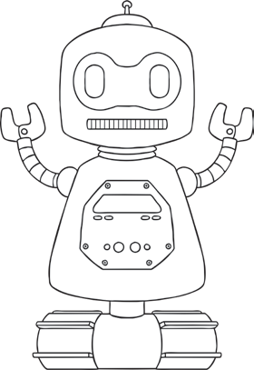
60
260
160

320

780

410

890

540

290

670

830

100 More and 100 Less Worksheet 2
Can you find 100 more that and 100 less that the number in the robot’s tummy?
E.g.
64
264
164

823

378

741

559

254

629

467

634

100 More and 100 Less Worksheet 3
Can you find 100 more that and 100 less that the number in the robot’s tummy?
E.g.
541
741
641

238

783

417

995

545

896

726

346

Ordering numbers to 1000 Worksheet 1
Fill in the spaces below with the numbers in order from smallest to largest.

21
26
12
16
29


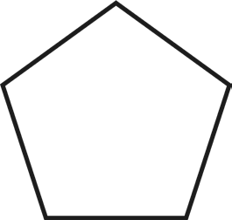76 67
48
49

16 61

66 77 17

94
44
84

18 81 14

720
170
210

270
710

Ordering numbers to 1000 Worksheet 2
Fill in the spaces below with the numbers in order from smallest to largest.

212
221
202
201
222

675
576
567
657
756

921
919 909

602
902
912
621
532

612 512

369
963
693

936
396

Estimating Addition Calculations

1. Which of these calculations give an answer of about 50?  34 + 17  13 + 45  28 + 31  45 + 18 | 2. Which of these calculations give an answer of about 60?  37 + 23  31 + 16  17 + 53  39 + 29 | 3. Which of these calculations give an answer of about 80?  72 + 25  47 + 31  29 + 32  35 + 27
4. Which of these calculations give an answer of about 100?  87 + 26  14 + 98  82 + 17  45 + 67 | 5. Which of these calculations give an answer of about 120?  84 + 23  46 + 76  98 + 32  53 + 56 | 6. Which of these calculations give an answer of about 150?  76 + 77  63 + 76  125 + 41  95 + 43
7. Which of these calculations give an answer of about 200?  120 + 60  50 + 180  130 + 70  140 + 160 | 8. Which of these calculations give an answer of about 300?  150 + 175  205 + 90  105 + 175  75 + 220 | 9. Which of these calculations give an answer of about 400?  234 + 129  294 + 76  301 + 102  241 + 156
10. Which of these calculations give an answer of about 110?  87 + 26  14 + 98  82 + 17  45 + 67 | 11. Which of these calculations give an answer of about 250?  124 + 221  113 + 135  26 + 231  175 + 55 | 12. Which of these calculations give an answer of about 350?  237 + 114  290 + 98  104 + 216  98 + 228
13. Which of these calculations give an answer of about 500?  245 + 275  135 + 450  285 + 180  345 + 160 | 14. Which of these calculations give an answer of about 750?  534 + 220  235 + 480  150 + 563  378 + 330 | 15. Which of these calculations give an answer of about 1000?  901 + 156  139 + 786  456 + 553  782 + 214

Estimating Addition Calculations

1. Which of these calculations give an answer of about 10?  34 - 23  64 - 45  27 - 12  98 - 77 | 2. Which of these calculations give an answer of about 20?  45 - 18  39 - 29  37 - 16  31 - 17 | 3. Which of these calculations give an answer of about 30?  92 - 54  31 - 12  37 - 16  76 - 47
4. Which of these calculations give an answer of about 40?  77 - 26  114 - 98  87 - 46  45 - 17 | 5. Which of these calculations give an answer of about 50?  84 - 23  124 - 76  98 - 32  53 - 11 | 6. Which of these calculations give an answer of about 60?  76 - 17  63 - 11  125 - 54  95 - 43
7. Which of these calculations give an answer of about 70?  120 - 60  250 - 180  130 - 70  200 - 160 | 8. Which of these calculations give an answer of about 80?  150 - 75  205 - 120  220 - 150  300 - 220 | 9. Which of these calculations give an answer of about 90?  234 - 129  294 - 213  301 - 102  241 - 153
10. Which of these calculations give an answer of about 100?  324 - 221  113 - 35  226 - 31  175 - 55 | 11. Which of these calculations give an answer of about 150?  237 - 114  290 - 98  404 - 216  380 - 228 | 12. Which of these calculations give an answer of about 200?  490 - 265  431 - 239  835 - 670  496 - 267
13. Which of these calculations give an answer of about 250?  345 - 98  513 - 245  268 - 31  459 - 181 | 14. Which of these calculations give an answer of about 350?  934 - 627  513 - 135  428 - 231  465 - 112 | 15. Which of these calculations give an answer of about 500?  934 - 427  613 - 145  728 - 231  1045 - 518

a) 459
Estimate on 0 - 1000 Number Line Worksheet

0
b) 213

1000

0
c) 987

1000

0 1000

d) 753

0 1000

e) 289

0 1000

f) 672

0 1000

g) 31

0
h) 814

0
1000

1000

a) 743
Estimate on 0 - 1000 Number Line Worksheet

500
b) 857

1000

700
c) 387

1000

300 500

d) 198

100 300

e) 449

200 500

f) 576

500 700

g) 610

450
h) 841

750
650

900

Writing Numbers in Words
Write the following numbers in words:

243 | Two hundred and forty-three
567
785
391
669
402
513
699
840
709
112
590
519
101

Writing Numbers in Words
Write the following words into numbers:

Three hundred and forty-six | 346
Six hundred and thirty-nine
Nine hundred and thirteen
Seven hundred and twenty-eight
Four hundred and six
Nine hundred and thirty
One hundred and four
Five hundred and thirty-five
Two hundred and twenty-two
Four hundred and sixty
Eight hundred and seventy-eight
Nine hundred and ninety-one
One hundred and ninety-nine
Five hundred and fifteen

Writing Numbers in Words
Write the following words into numbers and numbers into words:

561
902
Two hundred and fourteen
Six hundred and fifty-nine
327
Four hundred and twelve
Eight hundred and eight
880
660
Six hundred and sixteen
779
Three hundred and thirty-seven
819
Seven hundred and forty

