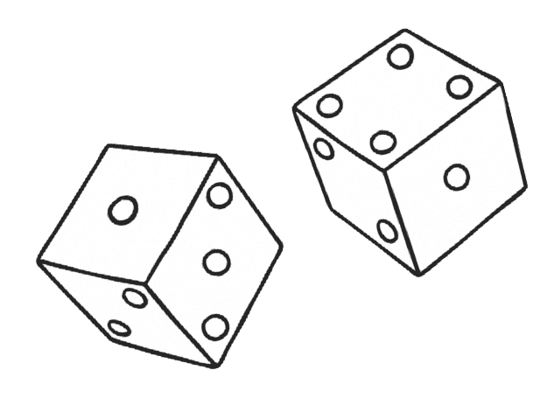
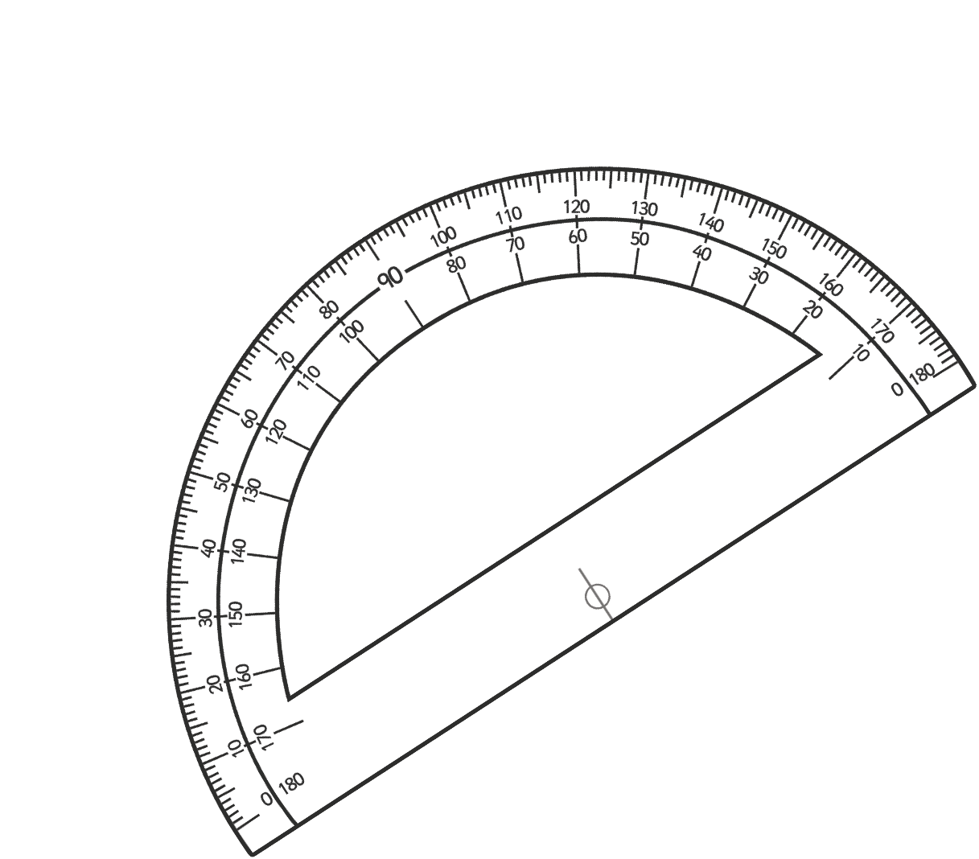
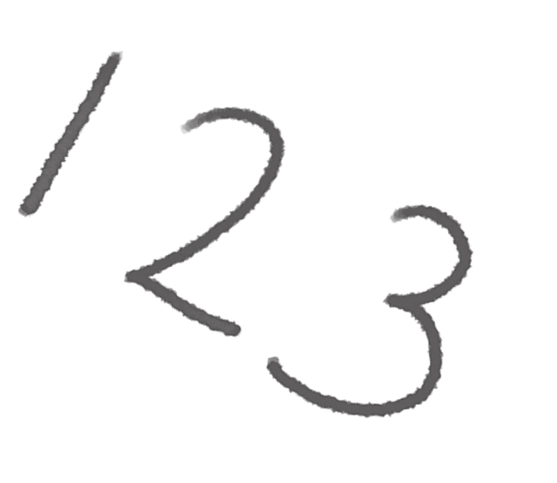
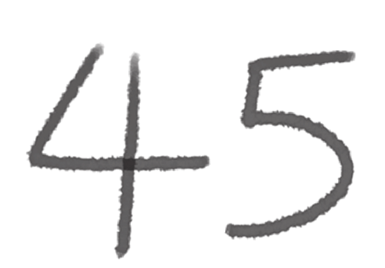
Clever Clogs
Maths Number
and Place Value Workbook
visit twinkl.com

Home Learning Clever Clogs
Number and Place Value
visit twinkl.com
Page 1 of 28
Revision

Worksheet

Page Number

Notes

Read, write, order and compare numbers to at least 1 000 000 and determine th e value of each digit.

- Number Partitioning Worksheet
- Ordering Numbers Worksheet
- Writing Numbers in words

3

4 - 6
7 - 9

Count forwards or backwards in steps of powers of 10 for any given number up to 1 000 000.

- Counting in Multiples of 10 from any number
- Counting forwards or backwards in Powers of Ten
- Counting Back in Powers of Ten Worksheets

10

11

12 - 14

Interpret negative numbers in context, count forwards and backwards with positive and negative whole numbers, inluding through 0.
- Counting Forwards and Backwards with Positive and Negatie Whole Numbers

15 - 16

Round any number up to
1 000 000 to the
nearest 10, 100,
1000, 10 000
and 100 000.

- Match the thousand to the number rounding worksheet
- Rounding 10 000’s worksheet
- Rounding 100 000’s worksheet

17

18 - 19
20 - 21

Home Learning
Number and Place Value
visit twinkl.com
Page 2 of 28
Revision

Worksheet

Page Number

Notes

Solve number problems and practical problems that involve all of the above.

- Counting Forwards and Backwards in Powers of 10 Word Problems
- Word Problems Worksheet
- Word Problems involving Negative Numbers.

22

23

24 - 25

Read Roman numerals to 1000
(M) and recognise years written in Roman numerals.

- Roman Numerals Worksheet
- Roman Numerals - Recognising Years

26

27 - 28

Number Partitioning - think Digit values (look at Q.5)
1.
+
+
+
+
+
1
2
=
2.
+
+
+
+
8
5
=
3.
+
+
+
+
+
2
3
=
4.
+
+
+
+
4
3
=
5.
500 000
+
+
+
+
10
=
6.
400 000
+
+
+
+
+
4
=
7.
800 000
+
+
+
+
8
=
8.
100 000
+
+
+
+
+
7
=
9.
+
+
+
+
+
7
9
=
700 000
visit twinkl.com
Page 3 of 28

20

8000

2

8

4

2

90

400

1000

10 000

20

300

6000

80

400

3000

70 000

600

3000

60 000

0

3

6

2

6

4

7

8

2

7

0

4

5

6

8

9




Ordering Numbers to 10 000
Fill in the spaces below with the numbers in order from smallest to largest.
2212
2012
1201
1022
2120
7676
6776
6677
7767
7776
4849
4948
4489
4994
449
1161
6161
1616
6611
6616
7220
2770
770
720
2707
visit twinkl.com
Page 4 of 28

Ordering Numbers to 100 000
Fill in the spaces below with the numbers in order from smallest to largest.
35 435
34 534
35 533
34 453
34 543
89 998
89 989
88 988
88 899
89 899
17 717
7771
7177
77 717
71 717
25 645
26 255
25 562
24 654
25 622
4091
491
4901
914
9410
visit twinkl.com
Page 5 of 28

Ordering Numbers to 1 000 000
Fill in the spaces below with the numbers in order from smallest to largest.
245 452
254 245
45 254
452 524
54 542
90 900
909 009
999 909
990 009
99 900
368 863
683 836
683 863
836 368
386 386
725 500
527 700
77 500
55 200
725 700
110 001
111 010
11 110
111 101
110 100
visit twinkl.com
Page 6 of 28

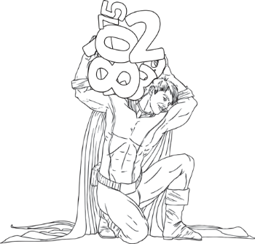
Writing Numbers to 1 000 000 in Words
Write the following words in numbers:
visit twinkl.com
Page 7 of 28

23 443

Twenty-three thousand, four hundred and forty-three

51 623

78 785

33 091

60 696

402 341

589 130

645 099

840 781

709 118

112 098

245 590

390 519

101 010

Writing Numbers to 1 000 000 in Numbers
Write the following words in numbers:
visit twinkl.com
Page 8 of 28

Two hundred and forty-five thousand, eight hundred and forty-six

245 846

Six hundred thousand, seven hundred and thirty-two

Nine hundred and thirteen thousand, five hundred and forty-one

Seven hundred and fifteen thousand, two hundred and twenty-eight

Four hundred and six thousand, seven hundred and ninety-four

Nine hundred and thirty-six thousand, two hundred and fifty-five

One hundred and seventeen thousand and four

Five hundred and thirty-five thousand, seven hundred and six

Two hundred thousand and twenty-two

Four hundred and eighty-eight thousand and sixty

Eight hundred and forty-eight thousand, nine hundred and three

Nine hundred and ninety-one thousand, one hundred and nineteen

One hundred and ninety-nine thousand, nine hundred and nineteen

Five hundred and fifteen thousand, one hundred and fifty-one

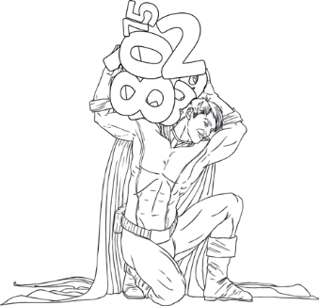
Writing Numbers to 1 000 000 in Words and Numbers
Write the following words in words and in numbers:
visit twinkl.com
Page 9 of 28

56 601

90 452

Two hundred and fourteen thousand, three hundred and twelve

Six hundred and fourteen thousand and fifty-nine

345 327

Four hundred thousand, two hundred and twelve

Eight hundred and eight thousand, eight hundred and eight

880 880

666 000

Six hundred and sixteen thousand, one hundred and sixty-one

797 779

Three hundred and thirty seven thousand and thirty seven

340 819

Three hundred and thirty-seven thousand and thirty-seven

Counting in Multiples of 10
Work out the correct numbers and then find the number trail in the grid below by counting backwards in 30s from the start each time.
535 787 + 10
+10
+10
+10
+10
879 213 + 20
+20
+20
+20
+20
756 128 + 50
+50
+50
+50
+50
919 399 + 60
+60
+60
+60
+60
754 321 - 10
-10
-10
-10
-10
134 094 - 70
-70
-70
-70
-70
visit twinkl.com
Page 10 of 28
START
394 432

394 492

394 585

394 705

394 505

394 805

394 905

394 118

394 402

394 372

394 625

394 957

394 891

394 635

394 292

394 312

394 342

394 302

394 645

394 665

394 232

394 888

394 282

394 485

394 499

394 680

394 685

394 605

394 578

394 252

394 222

394 192

394 102

394 072

394 042

393 565

393 798

393 411

394 162

394 132

393 082

394 012

393 565

393 166

393 374

393 641

393 445

393 052

FINISH 393 982

Counting on and Back in Powers of 10
Complete these sequences by counting on or back in powers of 10.
visit twinkl.com
Page 11 of 28
1
546 556
2
478 678
3
4503 4803
4
67 37
5
4904 5204
6
7834 5834
7
12 034 8034
8
23 894 33 894
9
55 903 35 903
10
190 780 390 780
11
345 000 315 000
12
786 457 886 457
13
212 903 112 903
14
1 347 500 1 347 900
15
23 678 340 24 678 340
16
83 900 000 80 900 000
17
510 000 000 520 000 000

Counting Back in Powers of 10
Count back from the given numbers in 10s (some answers are given)
1.
85
75

2.
137
117

3.
652
622

4.
901
861

5.
3087

6.
66 815

Count back from the given numbers in 100s (some answers are given)
1.
431
231

2.
900
600

3.
3312
3212

4.
9028
8628

5.
37 920

6.
209 372

visit twinkl.com
Page 12 of 28
Spot the error in this sequence:
192 902 191 802 191 702 191 602 191 502

Spot the error in this sequence:
98 621 98 611 98 601 98 691 98 581

Counting Back in Powers of 10 (2)
Count back from the given numbers in 1000s (some answers are given)
1.
4523
523

2.
9000
6000

3.
13 450
12 450

4.
102 342
100 342

5.
398 700

6.
1 341 299

Count back from the given numbers in 10 000s (some answers are given)
1.
43 920
33 920

2.
71 302
41 302

3.
90 000
50 000

4.
275 400
255 400

5.
733 450

6.
2 620 645

visit twinkl.com
Page 13 of 28
Spot the error in this sequence:
3 610 000 3 510 000 3 500 000 3 310 000 3 210 000

Spot the error in this sequence:
199 636 299 636 300 636 301 636 302 636

Counting Back in Powers of 10 (3)
Count back from the given numbers in 100 000s (some answers are given)
1.
690 382
490 382

2.
968 900
568 900

3.
1 220 765
1 120 765

4.
2 400 000
2 100 000

5.
6 256 923

6.
14 170 000

Count back from the given numbers in 1 000 000s (some answers are given)
1.
4 800 000
1 800 000

2.
7 034 200
5 034 200

3.
12 945 929
11 945 929

4.
37 803 549
33 803 549

5.
62 900 310

6.
231 500 000

visit twinkl.com
Page 14 of 28
Spot the error in this sequence:
778 100 000 777 100 000 776 100 000 776 900 000 774 100 000

Spot the error in this sequence:
52 900 000 51 900 000 51 800 000 49 900 000 48 900 000

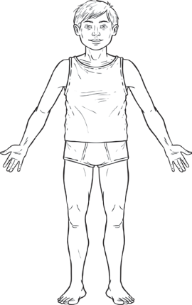
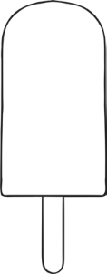

Counting Forwards and Backwards with Positive and Negative
Whole Numbers
I can count forwards and backwards with positive and negative whole numbers.
1.
Continue this sequence. Colour in the thermometer to match your sequence.
-3°c
-2°c

2.
Shade the thermometer lightly up to 20°C. Count backwards to continue this sequence and rub out as you go.
10°c
15°c
20°c

3.
Look at the ice lolly on the stick. Count forwards to complete the sequence. As you count forwards draw the ice lolly as it continues to melt in the rising temperature. You should have nothing remaining in the last picture.
4.
Continue this sequence backwards. As the temperature drops with each step, draw an extra item of clothing on the person.
11°c
17°c
23°c

visit twinkl.com
Page 15 of 28
-7°c
-4°c

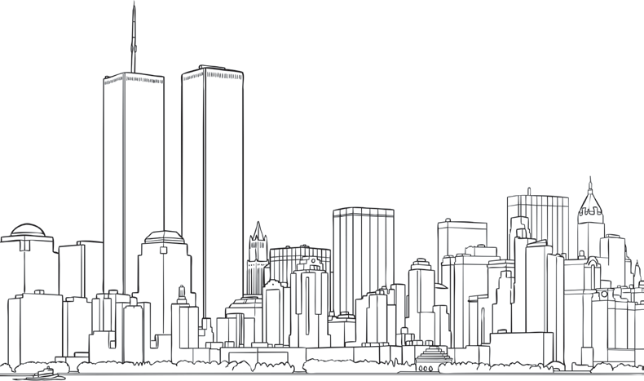
5.
Figure out the step in each sequence then use the number line below to help you count forwards and backwards to complete them.
A.
3
5 7

B.
-17°c
-12°c
-7°c

C.
4
9
19

D.
-31
17 25

E.
-£6
-£2

F.
11°c
15.5°c
20°c

6. Look at the temperatures for these cities.
Write the name of the warmest place in the box.
A.
B.
C.
D.
visit twinkl.com
Page 16 of 28
Minsk
St. Petersburg
Warmest
-15°c

-17°c

Stockholm
Edinburgh
Warmest
-4°c

-1°c

Reykjavik
London
Warmest
-10°c

-3°c

New York
Moscow
Warmest
-3°c

-1°c

The Nearest 1000
Match the number, how the number is rounded, and the number to which it is rounded. One has been done for you:
visit twinkl.com
Page 17 of 28

35 000

600 000

Nearest
Nearest
Nearest 10
Nearest
Nearest 100
Nearest
Nearest 1000

56 014

455 023

Challenge
Make your own for a friend to check. Some boxes have been completed or partly completed already. You need to include the arrows.
30 000
800 000
29 000
978 000
600 000
10 000
150 000
610 000
Nearest 100 000
Nearest 100 000
Nearest 1000
Nearest 10 000
Nearest 10 000
Nearest 10 000
Nearest 1000
Nearest 10 000
13 790
29 078
34 972
145 000
563 359
607 450
784 902
978 236

The Nearest 10 000
Write the ten thousands either side of the given number and mark it approximately on the number line. Then circle the 10 000 to which the given number is closer. (Remember 5 (5000) goes up).
a. 43 930
b. 67 509
c. 30 591
d. 45 662
e. 89 014
f. 12 300
g. 24 677
h. 476 545
i. 135 314
j. 270 013
k. 349 718
l. 455 450
visit twinkl.com
Page 18 of 28

The Nearest 10 000 (2)
Round the following numbers to the nearest 10 000.
Round the following populations to the nearest 10 000.
visit twinkl.com
Page 19 of 28
Places
Population
To the nearest 10 000
Iceland
317 900

Bahamas
346 000

Malta
416 333

Samoa
179 000

Maldives
314 000

Solomon Islands
536 000

Guyana
761 000

Cyprus
801 851

fiji
854 000

16 023

120 532

195 870

27 467

244 665

200 287

49 501

315 500

375 828

62 090

455 838

199 777

76 327

626 112

471 727

92 105

731 008

999 300

The Nearest 100 000
Write the ten thousands either side of the given number and mark it approximately on the number line. Then circle the 10 000 to which the given number is closer. (Remember 5 (5000) goes up).
a. 302 456
b. 745 900
c. 201 489
d. 485 200
e. 350 891
f. 120 780
g. 540 400
h. 267 080
i. 782 000
j. 932 910
k. 590 800
l. 967 302
visit twinkl.com
Page 20 of 28

I

The Nearest 100 000 (2)
Round the following numbers to the nearest 100 000.
Round the following populations to the nearest 100 000.
visit twinkl.com
Page 21 of 28
Places
Population
To the nearest 10 000
Iceland
317 900

Bahamas
346 000

Malta
416 333

Samoa
179 000

Maldives
314 000

Solomon Islands
536 000

Guyana
761 000

Cyprus
801 851

fiji
854 000

116 023

195 870

527 467

900 287

419 501

375 828

572 090

199 777

736 327

571 727

825 105

999 300


Counting Forwards and Backwards in Powers of 10 Word Problems
Answer the following questions:
1.
2.
3.
4.
5.
6.
7.
8.
9.
10.
What number is 1000 more than 3683? How many less is 5693 than 5703?
What number is 10 000 less than 1 234 508?
If I add 100 to a number I get 3467. What number did I start with? 23 890 is how many more than 13 890?
What number is 100 more than 45 901?
Add 10 000 to 270 801.
If I subtract 1000 from a number I get 19 230. What number did I start with? What number is 100 000 more than 671 023?
Subtract 1 000 000 from 30 782 901.
Write the following as calculations and solve them.
A.
7503 cars go over a bridge in February. In march, 1000 more cars go over the bridge than in February. How many go over the bridge in March?
B.
There are 30 903 books in a mobile library collection, but 1000 of these are on loan. How many books are left in the library?
C.
A girl wins £10 000 for winning a tennis competition. She has now won £35 600 in prize money altogether. How much had she won before winning the £10 000?
D.
A car has 34 678 miles on the milometer, but it had already travelled 100 000 miles. How many miles has it travelled altogether?
E.
A factory makes 305 800 glass bottles a day in March, which is 10 000 more than it made
in February. How many bottles did it used to make each day in February?
visit twinkl.com
Page 22 of 28

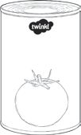
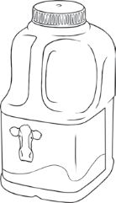
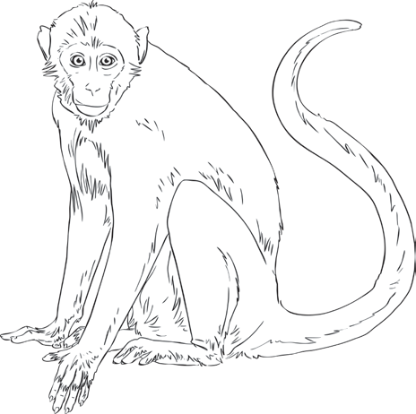
The Nearest 10 000 and 100 000
Solve the following word problems, rounding the answer as instructed.
1. A supermarket sells 143 687 litres of milk in one month.
How many litres is this to the nearest 10 000 and nearest 100 000?
2. There are 487 245 spectators at all the Premier League football matches on a Saturday.
How many is this to the nearest 10 000 and nearest 100 000?
3. A newspaper reports that about 160 000 people attended a parade.
How is this rounded and what is the range of the precise attendance?
4. 529 876 adults and 225 621 children visit a zoo in one year.
To the nearest 10 000 and nearest 100 000, how many people visit the zoo altogether?
5. A supermarket has 534 348 tins of tomatoes at a distribution centre. It sends out 67 782 in one shipment.
To the nearest 10 000, how many will be left?
6. A call centre receives about 75 000 calls per day.
To the nearest 10 000, how many calls does it receive in a working week (5 days)?
7. A swimming pool has 324 923 swimmers in the main pool and 591 023 swimmers in the leisure pool in one year.
To the nearest 100 000, how many swimmers do both pools get over the whole year?
8. A lorry driver travels 256 349 miles in one year, and 289 012 miles in the following year.
To the nearest 10 000 and 100 000, how many miles does the driver travel in both years?
visit twinkl.com
Page 23 of 28
Challenge
What happens if you round the numbers in the questions, then calculate the answers?

Word Problems Involving Negative Numbers
I can solve word problems involving negative numbers
Answer these questions. Adding numbers to the blank number lines may help you.
1.
The temperature at 6 p.m is 8°C, at 6 a.m. the next morning the temperature has dropped to
-7°C. How many degrees has the temperature fallen by?
2.
If you point to 11 on a number line and th.en count back 18, which number do you get to?
3.
The elevator in a skyscraper travels from floor 19 to the underground car park on level -4. How
many floors has it descended?
4.
An overdraft is a facility which means you can have a negative amount of money in your bank account. If a saver balance of -£19 and then paid £30 into his bank account, how much would he have available to spend?
5.
In a quiz, a team scores 2 points for each. correct answer and loses 5 points for each wrong answer. From the start of a game, a team gets 4 questions in a row correct, but then gets two questions wrong. How many points do they have?
visit twinkl.com
Page 24 of 28

6.
The temperature in New York is 4°C when the Christmas lights are switched on. By 9 a.m the next day, the temperature has fallen by 11 °C. What is the new temperature?
7.
Mrs. Jones buys a pair of skis and pays for them with her debit card. The skis cost £85 and she had £50 in her account. What is her new balance?
8.
Mr. Davies overspends during the month of September and goes £247 overdrawn. How much does he have left after his October wages of £847 are paid into his account?
visit twinkl.com
Page 25 of 28

Roman Numerals Worksheet
Translate these Roman numerals. Don’t forget to show your working out!
1. MD
4.
CXVI

2. MCD

5.
DCLX

3. XXXIV
6.
CXIII

Write these numbers in Roman numerals.
1. 35

4.
283

2. 100
5.
570

3. 99

6.
27

Arrange these numbers in size order.
XXXV, XL, XXX, LX, LV, L, XLV, LXV
, , , , , , ,
CL, CCC, CCL, C, CD, CC, L, CCCL
, , , , , , ,
Count in hundreds from one hundred.
C, CC, , , D, , , , ,
Count in five hundreds from five hundred.
D, , , , MMD, ,
Complete these calculations.
1. CD + DC =
4. XL + LX =
2. VI + IV =

5. CM + MC =
3. XI +IX =
6. CX +XC =

visit twinkl.com
Page 26 of 28

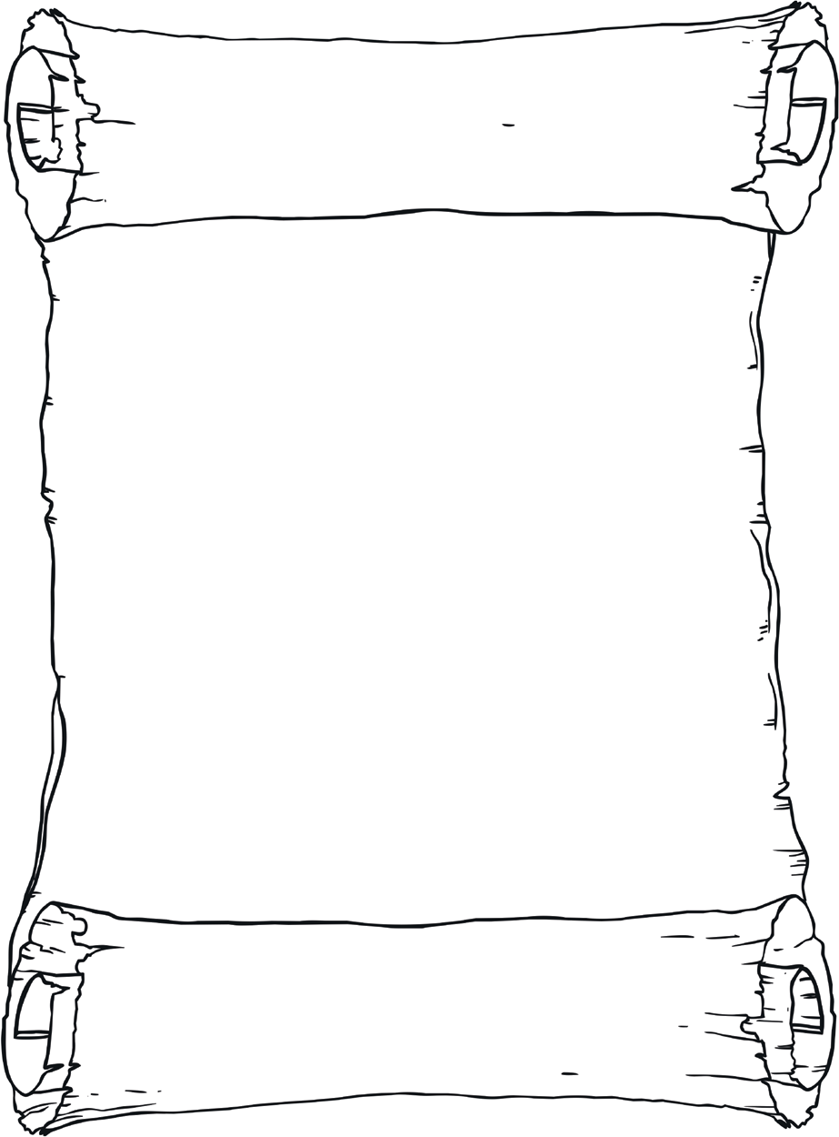
Roman Numerals - Recognising Years
I can convert years written in Roman numerals.
The rules that must be followed for accurate use of
Roman numerals are as follows:
1.
Symbols are written from left to right in value order.
To avoid having four characters in a row, some characters can be subtracted from others when placed BEFORE them.
I placed before V or X indicates one less. X placed before L or C indicates ten less.
C placed before D or M indicates a hundred less.
The seven basic Roman numerals in use are as follows:
I = 1
V = 5
X = 10
L = 50
C = 100
D = 500
M = 1000
2.
3.
4.
5.
This is how we would translate the year 1971.
1. Work out each of the following years in Roman numerals.
A.
B.
C.
visit twinkl.com
Page 27 of 28
1000
900
50
6
1956

2000
0
0
5
2005

1000
900
90
9
1990

1000
900
70
1
1971
M
CM
LXX
I
MCMLXXI

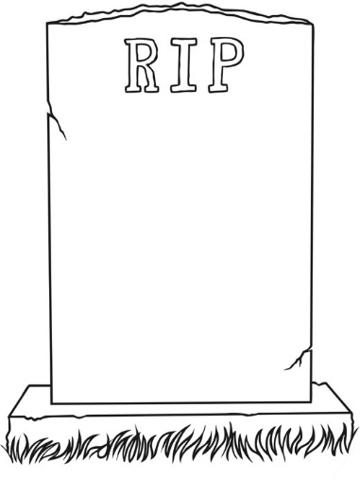
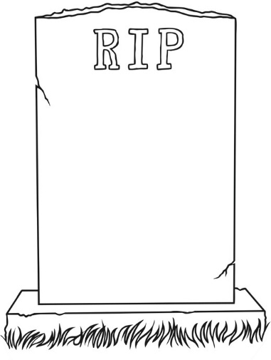
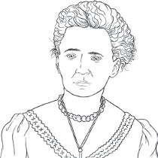
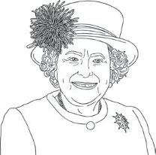
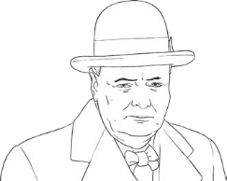
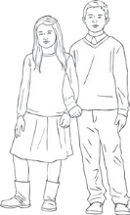

D.
2.
Work out which year the following historical figures were born.
Challenge
Can you work out how old these people were when they died and who lived the longest life?
Person 1 Born: CDLI
Died: DXII
Person 2
Born: MDCCLXXIII
Died: MDCCCXXIV
visit twinkl.com
Page 28 of 28
Who
Roman Numeral Year of Birth
Translation

Marie Curie

MDCCCLXVI I

Winston Churchill

MDCCCLXXIV

Queen Elizabeth

MCMXXVI

John Lennon

MCMXL

You!

1000
800
80
8
1888

