
Monday 25th January – Friday 29th January P7
Hi P7 PRINT this plan and follow the work set for your group. Tick off as you go.
It is hard to believe that you have already completed 3 weeks of home schooling already. Time flies! I hope that it is all running smoothly for you and you are finding the videos and PowerPoints helpful. Remember that you can email me any time. I have thoroughly enjoyed receiving your work and have been very pleased and impressed so keep it up. Let me know what other exciting things you are doing during lockdown. Perhaps some of you are enjoying cooking again or walking, cycling, jogging? Let me know what activities you are doing to keep yourselves entertained.
MATHS: TOPIC TIME Final week of Time
The A Team ONLY: Adult Support Required if possible.
PLEASE do the work in order:
- Do DAILY MENTAL MATHS Monday-Thursday Pgs 32+33 one per day and Friday Test. (Answers are in the folder I sent home)
- Do Hit the Button for 5 minutes. Focus on x8 ÷8 x9÷9 x11 ÷11 this week.
- Spend 5-10 minutes per day on The Daily Ten. Level 5 tables and division facts 2-11
Level 3 Addition Three-digit numbers, Level 3 Subtraction of Three-digit numbers +Ones
- Review the TIME videos and POWERPOINTS from the previous 2 weeks, if necessary!
- PLEASE play the Mathsframe Time Game from mathsframe.co.uk . There are variations so you can play different games/levels. This can also be accessed through Topmarks.
- Watch the PowerPoint Telling the Exact Time. You MUST study this PowerPoint please before the written work as it will help you.
- Complete NHM 4 Pgs. 85 and 86 in Maths Classwork Books (Answers scanned for parents)
- WATCH the video on Time Durations as it will teach you HOW to do the textbook work. Here is the link: https://youtu.be/e1l56frbqZE
- Complete NHM 4 Pgs. 87+88 (Answers scanned for parents)
- STUDY the PowerPoint on READING TIMETABLES. It is very good and will help you before you do the textbook work.
- Complete NHM 4 Pg. 89 (Answers scanned for parents)
Please do all corrections and try to understand your errors.

The Clever Clogs ONLY: PLEASE do the work in order!

- Do DAILY MENTAL MATHS Monday-Thursday Pgs 32+33 (one per day) and the Friday Test (Answers are in the folder I sent home!)
- Spend 5 minutes per day doing Hit the Button tables and division up to X12 ÷12
- Spend 10 minutes doing The Daily Ten: Level 6 Digit Values and Level 4 Addition 4 – digit numbers, Level 5 fractions and Level 4 Subtraction.
- Review the TIME videos and POWERPOINTS from the previous 2 weeks, if necessary!
- PLEASE play the Mathsframe Time Game from mathsframe.co.uk Select 24 hour. This can also be accessed through Topmarks.
- Work your way through the Year 7 Time Booklet to help consolidate your learning and understanding of TIME! (your parents are to collect this from school on Monday morning). If anything is hard, look at the videos and PowerPoints again. Some of this work is to be completed in your Maths Classwork Books and some can be completed in the booklet itself. (Ask your parents to mark your work – answer book provided! Then do any corrections and try to learn from your mistakes!)

The Brainy Bunch + The Masterminds ONLY: PLEASE do this work in order!
- Do DAILY MENTAL MATHS Monday-Thursday pgs 36+ 37 and the Friday Test
(Answers are in the folder I sent home!)
- Do 5-10 mins a day on DAILY TEN Level 6 Digit Values, Level 6 Times Tables, Level 6 Fractions!
- Review the TIME videos and POWERPOINTS from the previous 2 weeks, if necessary!
- PLEASE play the Mathsframe Time Game from mathsframe.co.uk Select 24 hour. This can also be accessed through Topmarks.
- Work your way through the Year 7 Time Booklet to help consolidate your learning and understanding of TIME! (your parents are to collect this from school). Some of this work is to be completed in your Maths Classwork Books and some can be completed in the booklet itself. (Ask your parents to mark your work – answer book provided! Then do any corrections and try to learn from your mistakes!)
- Find your ASSESSMENT BOOK and do TOPIC ASSESSMENT 11a and 11b (Answers scanned)
- CHALLENGE TASK: Find your NHM 6 Extension Book. Do E14 (Answers scanned for parents)
- MASTERMINDS ONLY: Also do E15 (Challenge Task) (Answers scanned for parents)

ENGLISH - Do in order!
RED+BLUE GROUPS ONLY:
- Do DAILY ENGLISH RED(AQE) DAYS 65-68 (one per day except Friday!)
- Do DAILY ENGLISH BLUE GROUP DAYS 49-52 (Plus test Days 40-50)
- SPELLINGS: RED+BLUE SPELLING GROUPS LEARN the third column of LIST 2 by FRIDAY! Do on a page or in a notebook. Get your parents to test you.
YELLOW SPELLING GROUP LEARN the third column of LIST 1 (30 words) by FRIDAY! Do on a page or in a notebook. Get your parents to test you.
- READING: Please read for 30 minutes per day (own choice of novel) and record.
- RED + BLUE: FIND in your P7 Resource Folder the photocopy titled ‘Crack-a-Dawn’ (Unit 2). BOTH GROUPS carefully read and complete the Do you remember? section and the More to Think About Section in your ENGLISH CLASSWORK BOOKS.
RED GROUP also do Now Try These section. Write in full sentences please! RED GROUP please email me your counting down poem and nonsense poem (Q.2+3) by Friday afternoon for me to read, thank you.
(NB I do not have answers for these so if your parent/s can please discuss and mark your work, that would be great. If that is not possible, then you can email your work to me)
- RED GROUP ONLY FIND the textbook titled Focus on Comprehension 3. READ +STUDY UNIT 1 The Water Cycle (TWAU LINK) COMPLETE PINK, GREEN and YELLOW SECTIONS. (Answers scanned for parents to mark work)

BLUE GROUP ONLY: FIND the textbook Practice in the Basic Skills English 4 and do Pg 24 A+B on PRONOUNS. This will help to consolidate your understanding of pronouns covered last week. Do in your English Classwork books. (Parents to correct, if possible, please – answers scanned)
- RED+BLUE GROUPS: Capital Letters Revision Tasks
a) STUDY the PowerPoint on Capital Letters-it is good for revision!
b) PRINT the Capital Letters Poster and glue into Facts to Learn Book
c) PLAY the Capital Letters Interactive PowerPoint Quiz
d) FIND the Nouns photocopy in your folder and turn to the next section Unit 8 Capital Letters. Complete all the work on Pg. 18+19 (Parents to correct, if possible, please – answers scanned!)
- AQE/RED GROUP ONLY: Complete ASSESSMENT TEST 3 – in folder (ANSWERS PROVIDED in your folder)

ENGLISH: GREEN GROUP ONLY:
- Do DAILY ENGLISH DAYS 49-52
- SPELLINGS: GREEN SPELLING GROUP: Refer to the NEXT 200 SPELLING LIST CHECKLIST you printed and LEARN the third column (20 words) by FRIDAY so do 4 per day. Do on a page or in a notebook. Get your parents to help you and test you, if possible.
- READING: Reading books for this week can be collected from school on Monday from 9am and please return the previous one. NB Switching to Mondays for drop off and collection in line with other classes. Read aloud every day to your parents please!
- FIND in your P7 Resource Folder the photocopy titled Crack-a-Dawn (UNIT 2) COMPLETE the Do You Remember Section ONLY! Q.1-7(Do in your English Classwork Books). (Parents to discuss and mark, if possible, please. There is no answer book)
5a) Print the Capital Letter Poster, (study it) and glue into Facts to Learn English
Book.
5b) Study the PowerPoint on Capital Letters
5c) Play the Interactive Capital Letter Quiz (this will help you to understand when
to use capital letters)
5d) Print and complete the worksheet on Capital Letters and full stops (Please send me a photo of this work)
6) Write or type me one paragraph about your home-schooling experience so far
and email me your response by Friday afternoon, please.

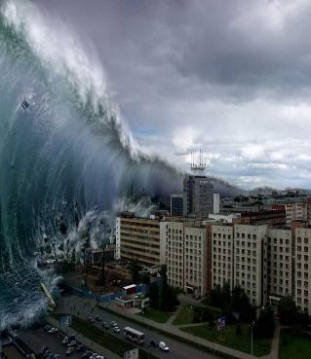
TWAU – NATURAL DISASTERS! It’s time for Tsunamis!

- ALL P7s STUDY the PowerPoint titled Tsunami Information PowerPoint. There is a link to a great video here. Discuss key facts with parents.
- PRINT and read the FACT FILE on Tsunamis and glue into TWAU Books.
- PRINT and COMPLETE the Tsunami Finding Facts Game and then glue into TWAU books. To do this you can collaborate with other members of your class, if possible OR work independently – your choice.
- Do the Tsunami Science Experiment and take a VIDEO of it!
- Upload your video to Google Classroom OR email me your video.
ENJOY! (You can adapt the experiment to suit the materials you have at home!)
ART + DESIGN

This week I would like you to draw OR paint a Tsunami!

- Watch the video showing you how to draw a tsunami. The link is…..
https://youtu.be/mdv_XfINVss


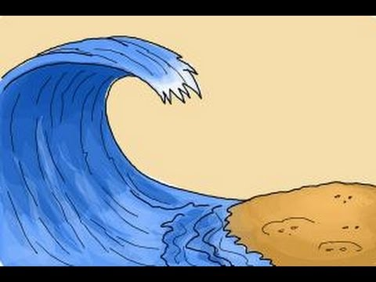
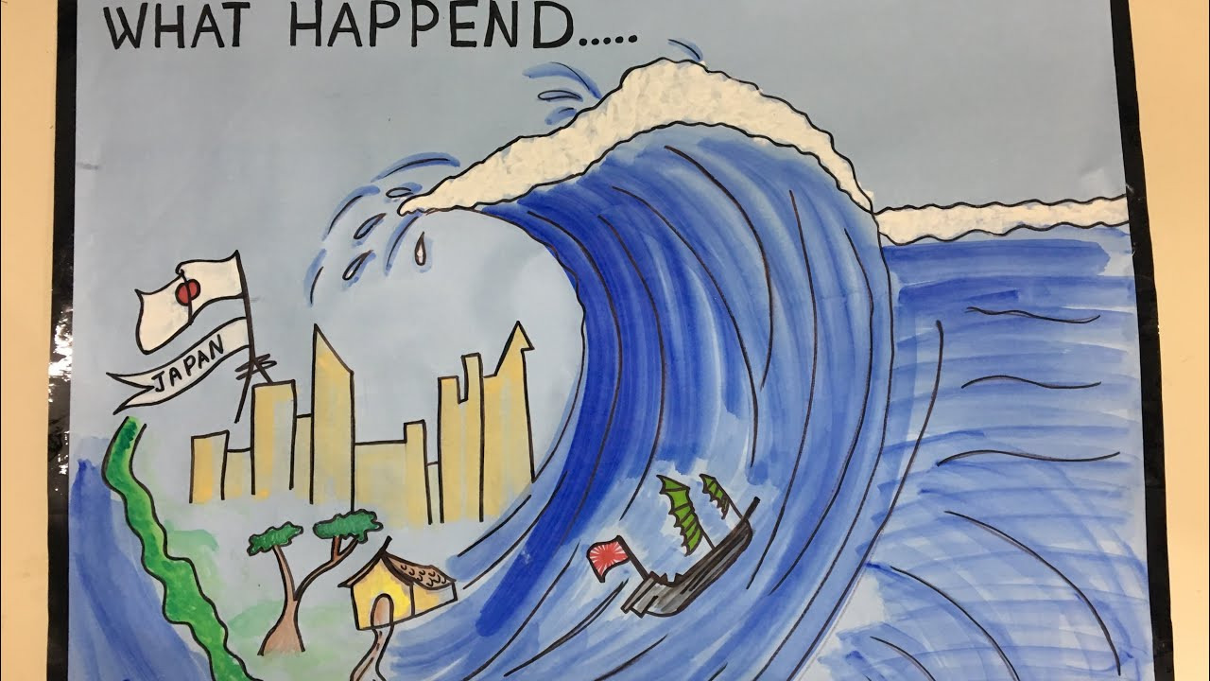
- Have a go! Please email me your artwork by Friday evening, if possible. Here are some ideas….



