
Monday 1st February – Friday 5th February P7
Hi P7 PRINT this plan and follow the work set for your group. Tick off as you go.
One month of Home Schooling completed- you must be experts by now! Do please try to use Google Classroom, rather than the school website, if possible. If you have any difficulties logging onto MySchool, get in touch and I will try to rectify the problem. Remember to email either one piece of work per day OR 4-5 pieces by Friday as per Mr Reid’s letter to parents. It is great to hear from you every week and to read and share your work online – a different method to the traditional display boards in school!


Pupils and Parents please note: I have decided to reduce the content of the workload this week to allow some ‘catch-up’ and to help you to consolidate your learning so far! The reduced content will also allow you some Well-Being time to enable you to do something creative, physical or relaxing – your choice! Those of you who are totally up-to-date can enjoy some extra ‘chilling time’ once this week’s content is complete.

MATHS: TOPIC: MONEY OR PERCENTAGES
The A Team ONLY: MONEY Adult Support Required if possible.
- Do DAILY MENTAL MATHS Monday-Thursday Pgs 34+35 and Friday Test.
- Do Hit the Button for 5 minutes. Focus on x12 ÷12 all week.
- Spend 5-10 minutes per day on The Daily Ten. Level 5 tables and division facts for 12
Level 4 ordering, Level 4+5 Digit Numbers
- Watch The A Team Maths Mastery Money PowerPoint with your parent/carer
- Glue MONEY POSTER into Facts to Learn Book
- Complete the A TEAM MONEY CUT+STICK ACTIVITY
- Complete the A TEAM COIN COMBINATION CHALLENGE
- Complete the A TEAM DIFFERENT COMBINATIONS OF COINS WORKSHEETS
- Complete NHM 3 Pg. 61, 62 and 63 (Answers scanned)

The Clever Clogs ONLY: PERCENTAGES

- Do DAILY MENTAL MATHS Monday-Thursday Pgs 34+35 and the Friday Test
- Spend 5 minutes per day doing Hit the Button tables and division up to X12 ÷12
- Spend 10 minutes on The Daily Ten: Level 6 Digit Values, Level 4 + Level 5 Ordering
- Watch the INTRODUCTION TO PERCENTAGES PowerPoint.
- Watch PowerPoint 2 PERCENTAGES.
- Study the INFORMATION SHEETS on Percentages and glue into Facts to Learn.
The PowerPoints and Information sheets will help explain the work.
- Complete the Percentage, Decimal, Fraction Colouring Activity (Answers Included)
- Complete CLEVER CLOGS Introduction to Percentages Worksheet (89)- scanned (Answers scanned)
- Complete CLEVER CLOGS Workbook Pages 38+39 – scanned (Answers scanned)
- Complete CLEVER CLOGS Using Percentages Worksheet (90) (Answers scanned)
- Complete CLEVER CLOGS Workbook Page 40 (Answers scanned)
- Complete the CC, BB+MM Fraction, Decimal, Percentage tables with answers
If you need any help to understand anything, please email.
Brainy Bunch + Masterminds ONLY: PERCENTAGES - REVISION!
- Do DAILY MENTAL MATHS Monday-Thursday pgs 38+ 39 and the Friday Test.
- Do 5-10 mins a day on DAILY TEN Level 6 Digit Values, Level 6 Ordering, Level 6 Fractions, Level 6 Division.
- Watch the INTRODUCTION TO PERCENTAGES PowerPoint.
- Watch PowerPoint 2 PERCENTAGES.
- Study the INFORMATION SHEETS on Percentages and glue into Facts to Learn Maths.
- Complete the Percentage, Decimal+Fraction and Colouring Activity (Answers Included)
- Complete the CC, BB+MM Fraction, Decimal, Percentage tables worksheets. NB: This is AQE Revision work! (Answers included for parents to mark)
- Complete SPMG 5 Pg 112 and workbook Pg 37 – scanned. (Answers scanned)
- Complete 4 Worksheets Finding Percentages of Quantities 25%, 10%, 5%, 1% (Answers included)
- Complete Finding 50%, 25%, 10% of Amounts Worksheets. (X3) (Answers Included)
If you need any help to understand anything, please email.

ENGLISH - Do in order!
RED+BLUE GROUPS ONLY:

- DAILY ENGLISH RED GROUP DAYS 69-72 (Plus test Days 60-70)
- DAILY ENGLISH BLUE GROUP DAYS 53-56
- SPELLINGS: (No new spellings this week!) REVISE and CONSOLIDATE Spellings learnt so far. Do on a page or in a notebook. Get your parents to test you.
- READING: Please read for 30 minutes per day (own choice of novel) and record.
- RED + BLUE: FIND in your P7 Resource Folder the photocopy titled ‘Noisy Neighbour Non-fiction: formal letter) (Unit 7). BOTH GROUPS carefully read and complete the Get Started section and the Try These Section in your ENGLISH CLASSWORK BOOKS. (RED GROUP NO EXTRA SECTION THIS WEEK!)
(NB I do not have answers for these so if your parent/s can please discuss and mark your work, that would be great. If that is not possible, then you can email your work to me)

- Complete the comprehension on Tsunamis. There are 3 versions. RED GROUP do version 3 pgs.11-14 and BLUE GROUP do version 2 pgs 6-9. (Answers included)

- RED+BLUE GROUPS: The following activities are short!
- STUDY the HOMOPHONE PowerPoint 1 for revision
- STUDY the Homophone Warm-up PowerPoint (Teaching PowerPoint)
- STUDY the remaining 3 Homophones PowerPoints on Where, There, To….
d) PRINT the Homophones Word Mat and glue into Facts to Learn Book
e) PRINT and complete the 3 Homophone Practice Sheets on Where, There, To etc (Answers included)
f) FIND in your P7 Resource folder the booklet with the first page saying Homophones. Complete this Page. (Parents to correct, if possible, please – answers scanned!)

ENGLISH: GREEN GROUP ONLY:
- Do DAILY ENGLISH DAYS 53-56
- SPELLINGS: GREEN SPELLING GROUP: REVISE all spellings learnt so far.
Do on a page or in a notebook. Get your parents to help you and test you, if possible.
- READING: Reading books for this week can be collected from school on Friday from 1-4pm and please return the previous one. Read aloud every day to your parents please!
- FIND in your P7 Resource Folder the photocopy titled ‘Noisy Neighbour Non-fiction: formal letter) (Unit 7). Carefully read and complete the Get Started section only in your ENGLISH CLASSWORK BOOKS
- Homophones: The following activities are very short…
- STUDY the HOMOPHONE PowerPoint 1
- STUDY the Homophone Warm-up PowerPoint with a parent! (Teaching PowerPoint)
- STUDY the remaining 3 Homophone PowerPoints on Where, There, To….
d) PRINT the Homophones Word Mat and glue into Facts to Learn Book
e) PRINT and complete the 3 Homophone Practice Sheets on Where, There, To etc
5) Complete Page 19 Practice in the Basic Skills Book 3 Vocabulary and Spelling. Write out definitions and words in full in English Classwork Books. Discuss with a parent, if possible. Send me a photo by Friday afternoon, please.


TWAU – NATURAL DISASTERS! Tsunamis continued!

- ALL P7s STUDY the 2 VIDEOS on Tsunamis. Here are the links:
https://www.youtube.com/watch?v=MfsugkikLJI
https://www.youtube.com/watch?v=V6cnFM55_Dw
They are also available to view on Google Classroom.
- PRINT and read the Tsunamis Around the World (Fact Cards) and make it into a small book.
- Test your Tsunami knowledge – Play the TSUNAMI PowerPoint Quiz
(It will explain what you don’t know!)
- PRINT and complete the Tsunami Research Writing Activity. To do this decide on ONE tsunami (see your Tsunamis Around the World mini book) research it in detail and then complete the sheet.
Please email me a photo or upload to google classroom, by Friday evening, please.

ART + DESIGN

This week I would like you to try a Tsunami model!

I have copied some photos for you to either copy or to get inspiration for your own. Adapt to suit the materials you have at home. Turn over for photos…
Have a go! Please email me your artwork by Friday evening, if possible. Here are some ideas….
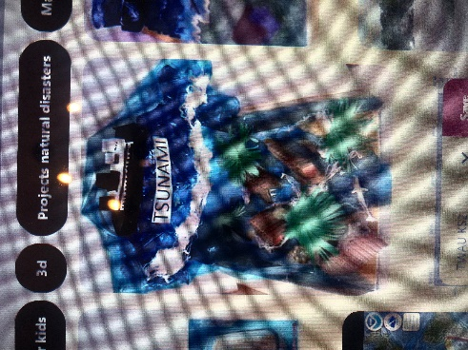
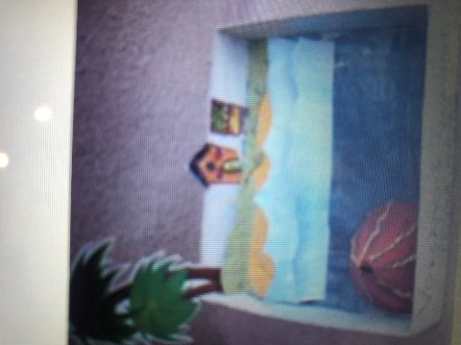
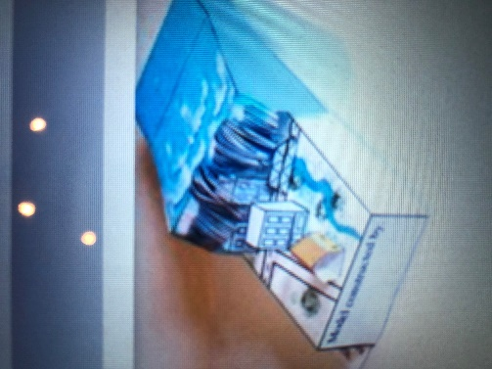
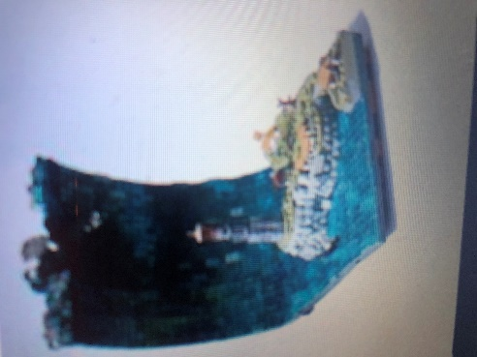
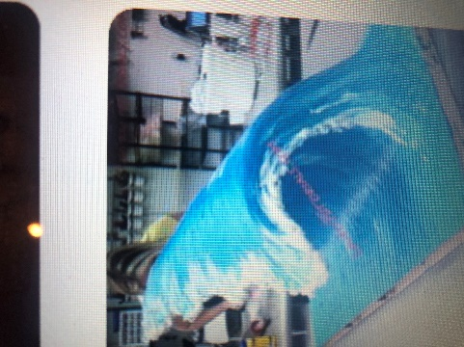
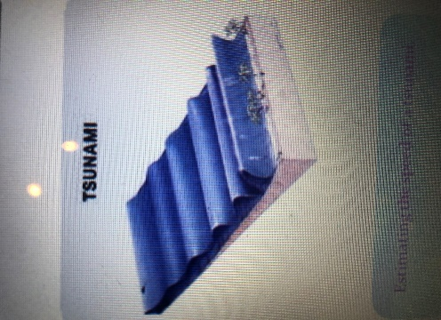

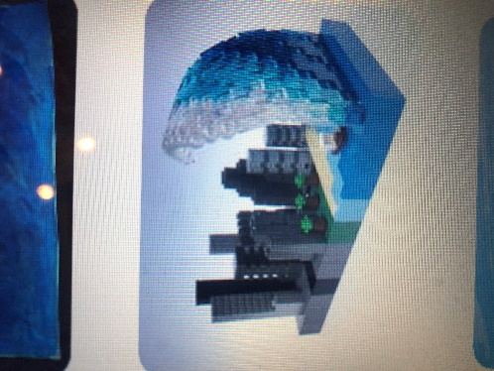
The main materials are cardboard and paint but you can use lego, modelling clay or whatever other materials/resources you have in your house!

Enjoy.

