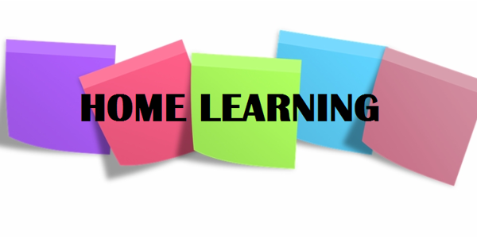

Hi P5,

I hope you are well and are settling in to this new (and very strange) way of life. I am missing you all. By now your parents will have come into school to collect your ‘At Home Learning’ packs, which contain your books and some other resources to help you continue with your learning at home.

I am going to outline a few activities that you may try to do complete this week. There is no pressure to complete all of the work as I understand that everyone’s circumstances are different but try to do what you can!

Numeracy

- Continue to complete one set of Mental Maths per day (Monday – Thursday).
- Vertical Subtraction: we were working on column subtraction before school finished and it would be great if you could practise this a bit more before Easter. If you can, complete:
- New Heinemann Maths 4 (NHM4) textbook, pages 34 – 37;
- In your NHM4 Assessment Book, complete check-ups 8 +9 and then Topic Assessment 3a and 3b;
3. Revision: To refresh your memory of column addition and subtraction, complete Number Tests 1, 2 & 3 in your SPMG2 Progress Test booklet.

Literacy
- Complete one set of Mental English per day;
- Comprehension Activities: Complete Unit 2 ‘Feelings’ (p. 8-11) in your comprehension activity booklet. You can record your answers to each section in your English Classwork Book.
- Spelling, Punctuation and Grammar: Find your S.P.G booklet and complete unit 1 (p. 4 + 5), on nouns, verbs and adjectives; I have uploaded a PowerPoint to refresh your memory on what these are. The link below will take you to a video that may also be helpful:
https://www.youtube.com/watch?v=CxrxUyxMnxA

Reading
Continue to read every day – it is so important. The Oxford Owl Website provides free access to hundreds of great e-books; I have linked the website below.

https://home.oxfordowl.co.uk/books/free-ebooks/

Newsround
If you would like to keep up to date with what is happening in the world at the moment, there are lots of great clips on CBBC Newsround (linked below)

https://www.bbc.co.uk/newsround#more-stories-2

Parents: Feel free to email me if you have any queries regarding any of the work I have set.

I hope you all have a lovely Easter holiday. Stay safe and eat lots of chocolate!

Miss Sharratt

