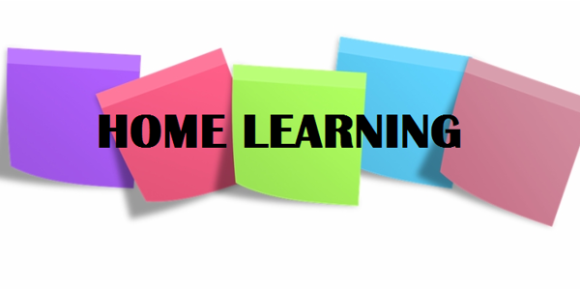

Hi P6,

I hope you all had a happy and restful Easter at home with your families. I’m sure you enjoyed the beautiful sunshine and ate plenty of chocolate treats. Having to stay at home for the past few weeks has been strange and I am missing the craziness of our classroom (honestly!).

The Easter break provided a good opportunity for us all to recharge but now it’s time to continue learning. I am going to outline some more activities for you to work through this week. As always, there is no pressure on you to complete all of the work but do try your best to do what you can!

Numeracy

- Continue to complete one set of Mental Maths per day (Monday – Thursday).
- Number Revision: To refresh your memory of addition, subtraction, multiplication and division, please complete Numbers Tests 1 and 2 in your SPMG3 Progress Test Booklet (same for those with Stage 2 booklet).
- Time: 24 hour time – In your Primary 6 Maths Booklet, complete the page entitled ’24-Hour Times’. The videos linked below, may help you to understand 24 hour time – it is a bit tricky so take your time and if possible, ask your parents if they could go over it with you.
https://www.youtube.com/watch?v=WM5rR7qR_ZY

https://www.bbc.co.uk/teach/class-clips-video/maths-ks2-using-timetables/zn2hy9q

- Complete NHM5 textbook pages 85-88 (If you have NHM4 textbook, stick with 12 hour time and complete pages 85-89). I will scan answers.
- In your Primary 6 Maths Booklet complete the next 2 pages – Pupil Sheets 56 and 57.
Literacy
- Complete one set of Mental English per day;
- Comprehension Activities: Complete Unit 2 ‘Food’ (p. 16-19) in your comprehension activity booklet. The activities in this Unit revise ‘synonyms’ and require you to write a set of instructions. I have uploaded two PowerPoint’s to refresh your memory on each of these topics. Follow these before recording your answers to each section in your English Classwork Book.
- Spelling, Punctuation and Grammar: Find your S.P.G booklet and complete page 11, entitled ‘Words with Similar Meanings’ – this provides more practice of synonyms. Then, complete Unit 2 (p. 6+ 7), on common and proper nouns.

Reading
Continue to read every day – it is so important. The Oxford Owl Website provides free access to hundreds of great e-books; I have linked the website below.

https://home.oxfordowl.co.uk/books/free-ebooks/

Newsround

Read all about Captain Tom- a 99 year old who has raised more than £17 million for the NHS by doing something very simple…
https://www.bbc.co.uk/newsround/52277760

Parents: Feel free to email me if you have any queries regarding any of the work I have set. Also feel free to forward any pictures / updates on how your child is progressing. Enjoy another week of home schooling.

Miss Sharratt

