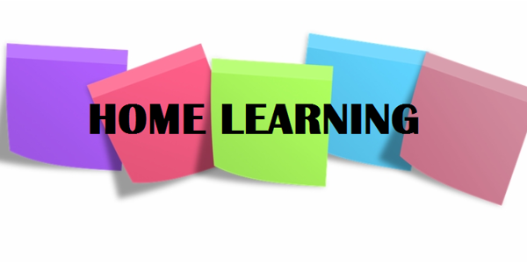

Hi P5,

I hope you all had another productive week at home. I can’t believe it is May already; April went so quickly and it is hard to believe that next month it will officially be summer!

I was delighted to receive so many updates, photographs (and even a few videos!) from you all last week; I really enjoy hearing from you. I have posted the videos on our class page, as well as a collage of some of the photographs, so that you can see what your classmates have been getting up to at home. If you would like to feature on the class page, ask your parents to send me some photos of you and I will include them in the next collage.

This weeks activities are outlined below. As always, there is no pressure on you to complete all of the work but do continue to do as much as you can.

Numeracy

- Continue to complete one set of Mental Maths per day (Monday – Thursday).
- Co-ordinates: This week we are going to start a brand new topic. Follow the PowerPoint that I have uploaded; this will explain co-ordinates to you.
Then, watch the videos that I have linked below:
- https://www.bbc.co.uk/bitesize/topics/zgthvcw/articles/z96k9qt
- https://www.bbc.co.uk/bitesize/clips/z7qmpv4
Once you have watched these, complete:
- NHM4 textbook pages 112- 113 in your Maths Classwork Book (I will scan answers for parents to mark);
- I have uploaded a fun co-ordinates emoji activity for you to try. Ask your parents to email me yours if you’re proud of it.

- Division: This week, try to divide numbers by 7 & 9.
Please complete:
- NHM4 textbook pp. 53- 56 (I will scan answers for parents to mark).
- In your NHM4 Assessment Book, complete Check-Ups 14, 15, 16, 17 & 18 (Answers scanned).
- Times Tables: Keep practising your times tables in your busy book.

Literacy
- Complete one set of Mental English per day (Days 16-20)
- Comprehension Activities: Complete Unit 9 ‘The Library’ (p. 36-39) in your comprehension activity booklet. Record your answers to each section in your English Classwork Book. You are also asked to write your own story about ‘Venger’s Truthpaste’; you will need to be creative for this. Think about who you might give a tube of truthpaste to and why? If you are able to do this, please write your final draft in your purple Writing Book and ask your parents to send me a photograph of your work, as I would love to read these. You might even draw a picture of a tube of Truthpaste!
- Spelling, Punctuation and Grammar:
- Find your S.P.G Plurals booklet (located behind the S.P.G booklet) and complete the next 4 pages, up to and not including the page entitled ‘Adding Suffixes’.
- I have uploaded activity sheets that focus on the four main sentence types; statements, questions, exclamations and commands. Please print these off; read the first page, insert your own examples in the spaces provided and stick this page into your English Facts to Learn Book. Then, complete the activities on page 2& 3; record your answers in your English Classwork Book.

*These activities should help with similar questions that appear in your daily Mental English activities.

TWAU

We are coming to the end of our Northern Ireland topic. Before we move on, I am setting you one final task to see how much you can remember. I want you to become a travel agent this week and design an information leaflet on publisher or by hand, which encourages tourists to visit NI.
You might choose to include sections on:
- The geography of NI;
- Climate;
- History;
- Places of interest;
- Food;
- Famous people;
- Fun Facts.

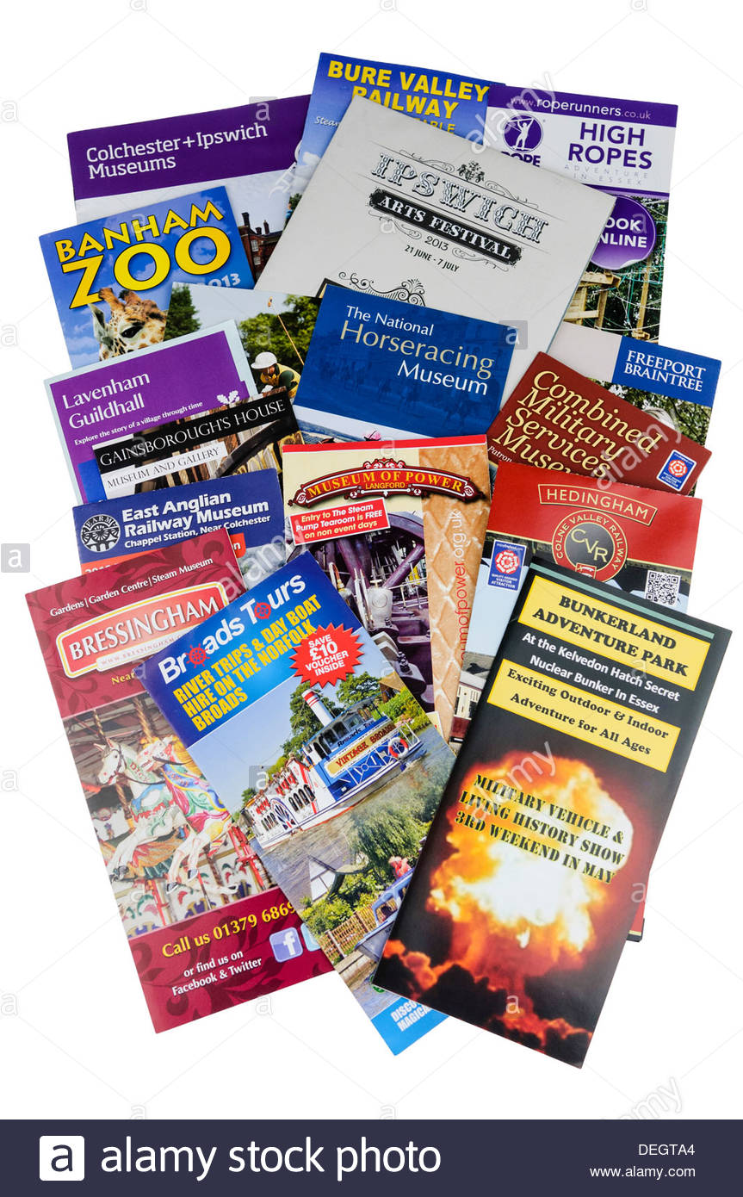
The information in your TWAU Books and your non-chronological reports (in your Writing Book), will help you with this. You may also use the Internet to conduct further research. Try to include some photographs to make your leaflet eye-catching. Ask your parents to email me your leaflets

Reading
Continue to read every day – it is so important. The Oxford Owl Website provides free access to hundreds of great e-books; I have linked the website below.

https://home.oxfordowl.co.uk/books/free-ebooks/

Newsround
Lots of boys and girls across the country have been making rainbow pictures for the NHS staff and other key workers, who are helping to fight COVID19. You can see some of these if you click on the link below:
https://www.bbc.co.uk/newsround/52485316

You may even try to design your own!

Parents: Again, feel free to email me if you have any queries regarding any of the work I have set. Please continue to forward any pictures / updates on how your child is progressing. Enjoy another week of home schooling – good luck!

Miss Sharratt

