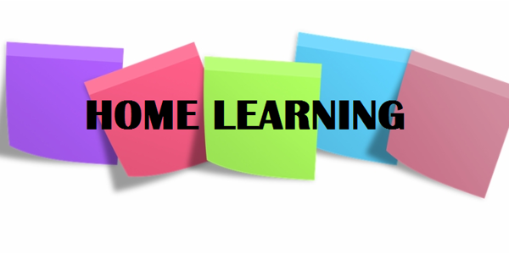

Hi P5,

I hope you had another enjoyable week and are continuing to learn lots at home. I have received lots of photographs this week, which prove that you are all working very hard. I have uploaded another collage to the class page; I have not been able to include all of the photographs as there were too many, but I will find a space for the rest in the coming weeks.

Many of your parents also emailed me to say how impressed they were with you last week, so well done! You are all making me very proud. Below, I have outlined some more activities for you to complete this week;

Numeracy

- Continue to complete one set of Mental Maths per day (Monday – Thursday).
- Data Handling: This week, you will interpret information from Pictograms, Venn and Carroll diagrams.
- Watch this video on Pictograms - https://www.bbc.co.uk/bitesize/clips/zg4d2hv
- Watch this video on Venn diagrams - https://www.bbc.co.uk/bitesize/clips/zhckq6f
- Watch this video on Carroll diagrams - https://www.youtube.com/watch?v=C02Bd3-tM9k
- Follow the Powerpoint entitled ‘Handling Data’;
- Complete NHM4 textbook, pages 121-123 in your Maths Classwork Book. (Answers scanned for parents)
- Division: I hope you all understand the ‘bus stop’ method of division after last week. You will practise this a little more this week.
- Complete NHM4 textbook pages 58-60 in your Maths Classwork Book. (Answers scanned for parents)
- Times Tables: Keep practising your times tables in your busy book.

Literacy
- Complete one set of Mental English per day (Days 26-30)
- Comprehension: Your instructions last week were great. This week, our focus is on non-Fiction texts.
- In your Comprehension Activity booklet, complete Unit 10 called ‘Finding Out’. Record your answers in your English Classwork Book.
*The following links may be useful if you do not have access to certain non-fiction books at home: https://kids.kiddle.co/ ; https://kids.britannica.com/kids/browse/dictionary; https://online.kidsdiscover.com/discover
- Spelling, Punctuation and Grammar:
- Find your S.P.G booklet and complete pages 22 and 14 entitled ‘Sounds Similar’ and ‘Making Sentences More Interesting’. These should be revision exercises for you. Record your answers on the sheet.
- Follow the PowerPoint on ‘Apostrophes’ and then complete page 9 in your SPG booklet called ‘The Apostrophe in Short Forms’.
TWAU

It’s finally time to begin our new topic, which is…the Titanic!! This is a great topic and I was really looking forward to teaching you about it in school but I’m sure you will have lots of fun learning about it at home.
- Open the PowerPoint called ‘Titanic Top Intro’ and follow the slides;
- Answer the questions found on slide 7 and record your answers in your TWAU books;
- Timeline Task: I want you to use the information on the final slides to create your own Titanic Timeline. I have uploaded iceberg and ship templates for you to use if you wish. Slide 8 explains this activity in more detail and shows you examples of completed timelines.

Reading
Continue to read every day – it is so important. The Oxford Owl Website provides free access to hundreds of great e-books; I have linked the website below.

https://home.oxfordowl.co.uk/books/free-ebooks/

Parents: Again, please email me if you have any queries regarding any of the work I have set. I am happy to help in any way that I can. Please alo continue to forward any pictures / updates on how your child is progressing – I really enjoy receiving these. Enjoy another week of home schooling – good luck!

Miss Sharratt

