Hey p5/p6!

I just wanted to send a little message to say hello and to let you know I’m missing you all. I hope you are all working hard for Miss Sharratt and your parents. I’ve seen some of your working from home pictures and it looks like you’ve all been working very hard! I hope between all the Maths and English you’ve been doing; you’re finding time to be creative too, maybe some artwork, playing board games or baking. I’ve been doing some baking. I’ve included some pictures to show you all.

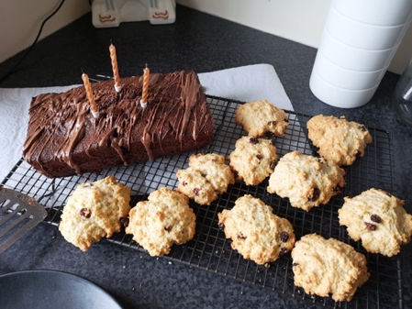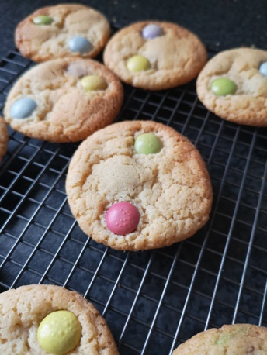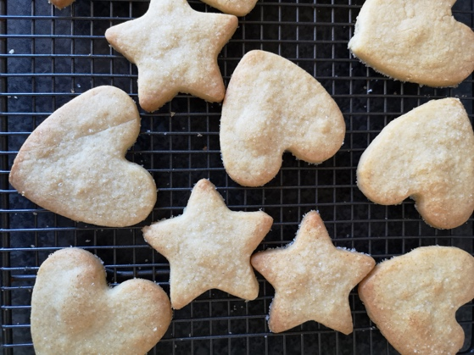

Keep sending your working from home photos in, as it’s so nice to see all the work you’ve been doing, and some of your amazing and colourful artwork it really brightens up my day.

From Mrs Livingstone

