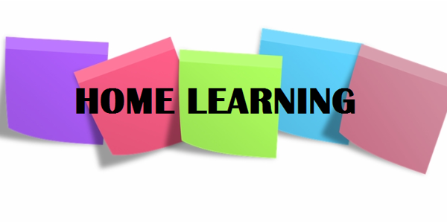

Hi P6,
I hope you had another productive week of home-schooling and found time to enjoy some of this lovely weather. We have lots of new photographs added to our collage this week; thank you so much to everyone who sent these in! You may have noticed a photograph of Christina in her Taekwondo uniform; she has just been awarded her green belt, after being graded online, which is a brilliant achievement. Well done Christina! It is lovely to hear positive news like this at the moment; if anyone else has achieved something that they are proud of, please get in touch to let me know! Also, if you haven’t already, check out the message that Mrs Livingstone wrote for you all on our class page.

Below, I have outlined some more activities for you to complete this week. As always, there is no pressure on you to complete all of this work but please continue to try your best and do what you can.

Numeracy
- Continue to complete one set of Mental Maths per day (Monday – Thursday).
2. Capacity: This week’s new topic is Capacity.
- Follow the PowerPoint entitled ‘Capacity’. Complete the exemplar activities contained within this PowerPoint and watch each video carefully.
- Print the ‘Capacity FTL sheet’ and stick it into your Maths Facts to Learn book;
- Complete NHM5 textbook, pages 97-99 (Answers scanned)
If you have NHM4 textbook, complete pages 101-102.
3. Volume:
- Follow the ‘Volume’ ppt;
- Print the ‘Volume FTL sheet’ and stick it into your Maths Facts to Learn book;
- Complete NHM5, pages 100-101 (Answers Scanned);
- Complete SPMG3, progress test 5;
- Complete the final 4 pages of your P6 Maths Booklet, from ‘Measures’ to ‘Build it’.
- Times Tables: Keep practising your times tables in your busy book. If you have completed this, keep playing ‘Hit the Button’ and ‘The Daily 10’.

Literacy
- Complete one set of Mental English per day;
- Comprehension Activities: In your Comprehension Activity Booklet, complete Unit 12, entitled ‘A Fairy Story’.
- Spelling, Punctuation and Grammar:
- Find your S.P.G booklet and complete the next two pages, which revise plurals.

TWAU
I was very impressed with some of your diary entries last week; they showed me how much you had learned about life on board the Titanic. This week, our focus is on the iceberg disaster and how the Titanic tragically sank. I have uploaded a PowerPoint called, ‘The Sinking of the Titanic’.
Follow the slides carefully and research the sinking of the Titanic online.
Then, use the information you have gathered to complete one of the following tasks:
- Write a Newspaper report on the sinking of the Titanic; include as many facts and figures as you can and remember to add photographs / drawings!
- Pretend you are a TV anchor and film yourself presenting a news report on the sinking of the Titanic, as it may appear on TV today. Include as many facts and figures as possible.

*There is more information on these tasks on slide 10.

Reading
Continue to read every day – it is so important. I have linked the Oxford Owl website below:
https://home.oxfordowl.co.uk/books/free-ebooks/

Audio Books
There is a great website called ‘Storyline Online’ which provides access to lots of audio books; celebrities often read the stories aloud! Feel free to give some of these a go, by following the link below:
https://www.storylineonline.net/

Parents: Please continue to email me photographs and updates of your child’s progress. If you have any queries regarding any of the work I have set, please get in touch. Enjoy another week of home schooling – good luck!

Miss Sharratt

