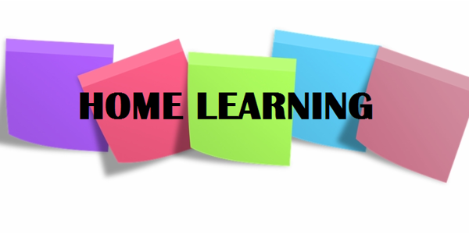

Hi P6,

We are almost at the end of our home-schooling experience and this will be the final guidance document that I publish on the website. I want to begin by saying how proud I am of each and every one of you, for working so hard during lockdown. I am disappointed that I wasn’t able to spend the last few months of school with you all in the classroom but you have done a great job of continuing your learning at home. I am sad that we won’t get to say goodbye in person, but I have loved being your teacher in P6 and am so proud of everything you have achieved. Please remind your parents to pop into school on Wednesday or Thursday of this week, to collect your art folders and something small from me, to say well done for working so hard! I would also ask that you return your NHM textbook and any other books or materials that you may have brought home, that belong to school.

I have not set many written English or Maths tasks this week; at this late stage in the term, we would have been unwinding and getting ready to celebrate the end of another successful school year. I have outlined a few activities that you may wish to complete at your own leisure.

I hope you have a great summer holiday. Enjoy the sunshine, stay safe and continue to make lovely memories with your family and friends at home.

Numeracy
- You can continue to complete one set of Mental Maths per day, if you wish;
- Play Hit the Button and The Daily 10 to practise times tables and other maths facts;
- Follow the PowerPoint on Multiples and Factors and play the games linked on slide 5.

Literacy
1. You can continue to complete one set of Mental English per day, if you wish;
2. As the school year draws to a close, I think it is important to look back and reflect on the positive experiences we enjoyed together as a class. I have uploaded a ‘Rear View Mirror’ worksheet, which encourages you to do this. Please complete it and feel free to send me a picture!
TWAU
I have uploaded one final PowerPoint on the Titanic; this week, you will to explore how the wreck was discovered and where the ship is now.

Your task this week is to design an informative poster that summarises the key information you have learned throughout the topic. I have included some photographs on slide 6 to inspire your creativity. Please stick this into your TWAU book once you have completed it.

Parents: You have done a great job of home-schooling your children during lockdown, however I am sure that many of you are relieved that it is coming to an end. I hope that you can all enjoy a well-deserved break. Please call in to school on Wednesday or Thursday of this week to collect your child’s belongings and to return the New Heinemann Maths textbooks provided during lockdown. I hope to see some of you then (from a safe distance!)

Miss Sharratt

